E-Project Eproject Guide
Beauty Of Beaches

Group Members

- ZAIN UL HAQ
Student:1730727

- ZAYAN AHMED
Student:1730756

- RAHIM AHMED
Student:1730767

- STEPHNES BHATTI
Student:1733004

- MUHAMMAD MUSTAFA
Student:1730760

Faculty Members

Teacher: Miss Neha Shah
Coordinator: Miss Munazzah Khan

Table Of Content

- Introduction
- Objective of the Project
- Tools & Technologies Used
- System Requirements
- Key Modules & Features Description
- Project Code Snippets
- Website Screenshots
- Tak Sheet
- Conclusion

INTRODUCTION

BEAUTY OF BEACHES

The beauty of beaches has always attracted people with its natural charm, peaceful environment, and refreshing atmosphere. Beaches are a wonderful combination of golden sand, sparkling blue water, gentle waves, cool sea breeze, and beautiful sunsets. They provide a perfect place for relaxation, recreation, tourism, and spending quality time with family and friends. In today's digital world, technology provides an excellent way to explore and present the natural beauty of beaches. A well-designed web application can provide users with useful information about different beaches, their locations, attractions, activities, and natural surroundings in an interactive and attractive manner. Keeping the above concept in mind, this E-Project, “Beauty of Beaches”, is designed to provide an interactive platform where users can explore and learn about beautiful beaches. The project demonstrates how web technologies can be used to present information in an organized, user-friendly, and visually appealing way.

OBJECTIVE OF THE PROJECT
The main objective of the “Beauty of Beaches” project is to develop an attractive and informative web application that provides users with information about beaches and their natural beauty.
- Provide information about famous and beautiful beaches.
- Display attractive images and descriptions of beaches.
- Provide information about beach locations and attractions.
- Help users explore different beaches through an easy-to-use interface.
- Present information in an organized and visually appealing manner.
- Provide details about activities that can be enjoyed at beaches.
- Demonstrate the practical implementation of web development concepts.
- Develop a larger and more useful application by integrating different features.
- Improve technical skills through real-life project implementation.
- Create a user-friendly environment for exploring the beauty of beaches.
TOOLS & TECHNOLOGIES USED
HTML5: Semantic markup for structuring web pages, sections, and embedded media elements.
CSS3: Custom styling, layout management, animations, and responsive UI adjustments.
Bootstrap 5: Mobile-first responsive framework used for grid layouts, UI elements, navigation bars, and modals.
Bootstrap Icons: Scalable vector icons for interactive buttons, ratings, and navigation elements.
JavaScript (ES6): Client-side scripting for interactive features, slider logic, state management, and UI events.
jQuery & jsPDF: External libraries utilized for dynamic manipulation and exporting destination/wishlist details into downloadable PDF format.
Google Fonts: Typography enhancement ('Inter' and decorative sans-serif fonts) for improved readability.

SYSTEM REQUIREMENTS
Hardware Requirements
- Processor: Intel Core i3 (2.0 GHz or higher) / AMD equivalent
- RAM: Minimum 2 GB (4 GB recommended)
- Storage: 100 MB available disk space for web application files
Software Requirements
- Operating System: Windows 10/11, macOS, Linux, or modern mobile operating systems (Android/iOS)
- Web Browser: Google Chrome, Mozilla Firefox, Microsoft Edge, or Safari (Modern browser with JavaScript enabled)
KEY MODULES & FEATURES DESCRIPTION
- Code Editor: Visual Studio Code / Sublime Text (For development)
  - Home Page & Hero Banner: Features an interactive image slider showcase with dynamic text overlays, rating badges, and call-to-action buttons for trip planning.

  - Beach Gallery: A responsive image gallery displaying top international beaches with hover zoom effects and high-resolution visuals.

  - Zones (Tabbed Section): Categorizes beaches into geographical or activity-based zones with dynamic tab switching, heart-icon wishlist functionality, and PDF download triggers.

  - Travel Table & Route Finder: An organized tabular view detailing beach locations, ideal travel times, and distance/route guides for travelers.

  - Traveler Reviews & Star Ratings: An interactive review module featuring user feedback, filterable star ratings (5-star, 4-star, etc.), and real-time interactive star selectors.

  - Contact & Inquiry Form: A structured form for visitors to submit inquiries, feedback, or booking consultations.

  - Wishlist & PDF Download Feature: Allows users to save their favorite beaches using interactive heart icons and generate/download customized travel summaries in PDF format via jsPDF.

Screenshots

Nav bar:-
Html:
<nav class="navbar navbar-expand-lg navbar-dark shadow-sm fixed-top">
<div class="container-fluid px-4">

<a class="navbar-brand" href="#home">
<img src="images/logo_bottom_line_white.png" alt="Logo" width="75px" height="75px">
</a>

<button class="navbar-toggler nav-bg" type="button" data-bs-toggle="collapse" data-bs-target="#mainNavbar">
<span class="navbar-toggler-icon"></span>
</button>

<div class="collapse navbar-collapse" id="mainNavbar">

<ul class="navbar-nav mx-auto mb-2 mb-lg-0">
<li class="nav-item"><a class="nav-link active" href="#home">Home</a></li>
<li class="nav-item"><a class="nav-link" href="#beaches">Beaches</a></li>
<li class="nav-item"><a class="nav-link" href="#gallery">Gallery</a></li>
<li class="nav-item"><a class="nav-link" href="#routes-section">Routes</a></li>
<li class="nav-item"><a class="nav-link" href="#about">About</a></li>
<li class="nav-item"><a class="nav-link" href="#contact">Contact</a></li>
</ul>
</div>
<div class="guest">
<span class="online"></span>
Visitors: <strong id="visitor-count">1</strong>
</div>
</div>
</nav>

Css:
/* navbar */
.container-fluid{
width: 100%;
height: 80px;
position: sticky;
}
.navbar {
background-color: #1a3d63 !important;
padding: 15px 30px;
}
.navbar-brand img {
width: 120px;
}
.navbar-nav {
gap: 20px;
}
.nav-link {
color: #f6fafd !important;
font-size: 16px;
}
.nav-link:hover {
color: white !important;
}
.nav-link.active {
color: #b3cfe5 !important;
border-bottom: #b3cfe5 2px solid;
}
.navbar-collapse{
background-color: #1a3d63 !important;
color: #f6fafd;
padding: 15px;
border-radius: 8px;
}
.guest{
color: #f6fafd;
}
.online {
display: inline-block;
width: 10px; height: 10px;
background: #4ee17b;
border-radius: 50%;
box-shadow: 0 0 8px #4ee17b;
}
#visitor-count { color: #5eb8f0; font-weight: 700; }

Js Script:
////////////// visitor count //////////////////////
(function () {
let count = sessionStorage.getItem("session_views");
if (!count) { count = 1; }
else { count = Number(count) + 1; }
sessionStorage.setItem("session_views", count);
const el = document.getElementById("visitor-count");
if (el) { el.innerText = count; }
})();

Hero:-
Html:
<!-- hero -->
<div class="card">
<div class="banner-text-container">
<h1 class="banner-title">
Beauty Of <span>Beaches</span>
</h1>
<p class="banner-description">
Where every wave tells a story.
</p>
<button class="banner-btn"><a href="#beaches">Explore Beaches →</a></button>
</div>
<img src="images/hero img.png" alt="" width="100%" height="40%">
</div>
Css:
/* hero */
.card {
position: relative;
margin: 0%;
border: none;
width: 100%;
height: 90vh;

}
.card img {
display: block;
width: 100%;
height: auto;
min-height: 350px;
object-fit: cover;
}
.banner-text-container {
position: absolute;
top: 30%;
transform: translateY(-50%);
left: 5%;
max-width: 50%;
}
.banner-title{
color: #f6fafd;
font-size: 2.5rem;
font-family: 'Times New Roman', Times, serif;
font-weight: bolder;
line-height: 1.2;
margin-bottom: 12px;
}
.banner-title span {
color: #4a7fa7;
font-family: 'Brush Script MT' , cursive;
}
.banner-description {
color: #cbd5e1;
font-size: 1.5rem;
font-family: 'Courier New', Courier, monospace;
line-height: 1.5;
margin-bottom: 20px;
opacity: 0.9;
}
.banner-btn {
color: #1a3d63;
background-color: #b3cfe5;
border: none;
border-radius: 10px;
height: 40px;
padding: 0 25px;
font-weight: bold;
cursor: pointer;
transition: background 0.3s ease;
}
.banner-btn a{
text-decoration: none;
}
.banner-btn a:hover{
color: aliceblue;
}
.banner-btn:hover {
background-color: #1a3d63;
color: #b3cfe5
}
@media (max-width: 992px) {
.banner-text-container {
max-width: 70%;
}
.banner-title {
font-size: 2rem;
}
}
@media (max-width: 576px) {
.banner-text-container {
max-width: 90%;
left: 20px;
}
.banner-subtitle {
font-size: 11px;
}

.banner-title {
font-size: 1.5rem;
margin-bottom: 8px;
}
.banner-description {
font-size: 0.85rem;
line-height: 1.4;
margin-bottom: 15px;
}
.banner-btn {
height: 35px;
padding: 0 18px;
font-size: 0.85rem;
}
}
Wave:-
Html:
<!-- wave -->
<div class="wave-top">
<svg xmlns="http://www.w3.org/2000/svg" viewBox="0 0 1440 320" style="display: block; width:100%; height:auto;">
<path fill="#ffffff" fill-opacity="1" d="M0,160L48,154.7C96,149,192,139,288,149.3C384,160,480,192,576,186.7C672,181,768,139,864,128C960,117,1056,139,1152,154.7C1248,171,1344,181,1392,186.7L1440,192L1440,320L1392,320C1344,320,1248,320,1152,320C1056,320,960,320,864,320C768,320,672,320,576,320C480,320,384,320,288,320C192,320,96,320,48,320L0,320Z"></path>
</svg>
</div>

Css:
.beach-section{
position: relative;
background-color: #00b4d8;
}
.wave-top{
position: absolute;
left: 0;
/* bottom: 80px; */
top: 300px;
width: 100%;
height: auto;
overflow: hidden;
line-height: 0;
z-index: 10;
}

Beahes Section:-
Filter buttons:-
html:
<div class="header-section">
<h1 class="page-title"> World Beach Directory</h1>
<div class="filter-container">
<button onclick="filterZone('north')" class="fltr-btn active" id="btn-north">North Zone </button>
<button onclick="filterZone('east')" class="fltr-btn" id="btn-east">East Zone </button>
<button onclick="filterZone('west')" class="fltr-btn" id="btn-west">West Zone </button>
<button onclick="filterZone('south')" class="fltr-btn" id="btn-south">South Zone </button>
</div>
</div>

Css:
.header-section {
text-align: center;
padding: 40px 20px 20px;
}

.page-title {
font-family: 'Playfair Display', Georgia, serif;
font-size: 3rem;
font-weight: 700;
color: #f2f8fd;
text-shadow: 0 4px 18px rgba(0, 0, 0, 0.5), 0 0 30px rgba(94, 184, 240, 0.35);
margin-bottom: 25px;
}

/* ---------- FILTER BUTTONS ---------- */
.filter-container {
display: flex;
justify-content: center;
gap: 12px;
flex-wrap: wrap;
margin-bottom: 35px;
}

.fltr-btn {
height: 48px;
padding: 0 26px;
border-radius: 25px;
background: #0f3a68;
border: 1.5px solid rgba(143, 208, 247, 0.35);
color: #b8e0fa;
font-weight: 500;
font-size: 16px;
cursor: pointer;
transition: all 0.3s ease;
box-shadow: 0 4px 10px rgba(0, 0, 0, 0.3);
}

.fltr-btn:hover {
background: #1c5f9c;
color: #ffffff;
border-color: #8fd0f7;
transform: translateY(-3px);
box-shadow: 0 0 18px rgba(94, 184, 240, 0.5);
}

.fltr-btn.active {
background: linear-gradient(135deg, #b8e0fa, #5eb8f0);
color: #04152b;
border-color: #ffffff;
font-weight: 700;
box-shadow: 0 0 22px rgba(94, 184, 240, 0.7);
}

Js:
// Filtering function for 4 specific zones
function filterZone(zone) {
// Update Active Class on Buttons
$(".fltr-btn").removeClass("active");
$("#btn-" + zone).addClass("active");

// Hide all card wrappers and show selected zone cards
$(".card-wrapper").hide();
$("." + zone).fadeIn(300);
}
Cards:-
Html:
<div class="col-lg-4 col-md-6 col-sm-12 card-wrapper north">
<div class="beach-card" onclick="openModal('reynisfjara-beach-modal')">
<img src="https://images.unsplash.com/photo-1507525428034-b723cf961d3e?auto=format&fit=crop&w=600&q=80" alt="Reynisfjara Beach">
<div class="info">
<span>📍</span>
<div class="text">
<p class="name">Reynisfjara Beach</p>
<p class="place">Vik, Iceland</p>
</div>
<button class="arrow" aria-label="Details">→</button>
</div>
</div>
</div>

Css:
.card-wrapper {
display: flex;
justify-content: center;
margin-bottom: 30px;
}

.beach-card {
width: 100%;
max-width: 280px;
border-radius: 20px;
overflow: hidden;
background: #0a2a4f;
color: #ffffff;
border: 1px solid rgba(143, 208, 247, 0.2);
box-shadow: 0 8px 20px rgba(0, 0, 0, 0.35);
transition: transform 0.3s ease, box-shadow 0.3s ease, border-color 0.3s ease;
cursor: pointer;
}

/* GLOW EFFECT on hover */
.beach-card:hover {
transform: translateY(-8px);
border-color: #8fd0f7;
box-shadow: 0 0 22px rgba(94, 184, 240, 0.65),
0 0 55px rgba(94, 184, 240, 0.35),
0 18px 30px rgba(0, 0, 0, 0.5);
}

.beach-card img {
width: 100%;
height: 200px;
object-fit: cover;
display: block;
transition: transform 0.5s ease;
}

.beach-card:hover img {
transform: scale(1.08);
}

.info {
display: flex;
align-items: center;
gap: 12px;
padding: 16px;
background: #0a2a4f;
}

.info span {
font-size: 1.2rem;
}

.text {
position: relative;
flex: 1;
height: 40px;
overflow: hidden;
}

.name {
position: absolute;
top: 8px;
margin: 0;
width: 100%;
font-weight: 500;
font-size: 16px;
color: #ffffff;
white-space: nowrap;
text-overflow: ellipsis;
overflow: hidden;
transition: transform 0.3s ease;
}

.place {
position: absolute;
top: 8px;
margin: 0;
width: 100%;
font-size: 13px;
color: #8fd0f7;
white-space: nowrap;
text-overflow: ellipsis;
overflow: hidden;
opacity: 0;
transform: translateY(15px);
transition: transform 0.3s ease, opacity 0.3s ease;
}

.beach-card:hover .name {
transform: translateY(-10px);
}

.beach-card:hover .place {
opacity: 1;
transform: translateY(8px);
}

.arrow {
border: 1.5px solid #8fd0f7;
border-radius: 50%;
width: 36px;
height: 36px;
background: transparent;
color: #b8e0fa;
display: flex;
align-items: center;
justify-content: center;
font-size: 16px;
cursor: pointer;
transition: all 0.3s ease;
}

.beach-card:hover .arrow {
background: #8fd0f7;
color: #04152b;
box-shadow: 0 0 14px rgba(143, 208, 247, 0.9);
}

Modal:-
Html:
<!-- Reynisfjara Beach Modal -->
<div class="overlay" id="reynisfjara-beach-modal">
<div class="modal-box">
<div class="left">
<div class="photo" style="background-image: url('https://images.unsplash.com/photo-1507525428034-b723cf961d3e?auto=format&fit=crop&w=600&q=80')">
<span class="tag">📍 Iceland</span>
</div>
<h2>Reynisfjara Beach</h2>
<p class="loc">📍 Vik, Iceland</p>
<p class="desc">A dramatic black sand beach with basalt columns and powerful Atlantic waves.</p>
<div class="stats">
<div>Best Time<b>Jun - Aug</b></div>
<div>Avg. Temp<b>5°C - 13°C</b></div>
<div>Beach Type<b>Black Sand</b></div>
<div>Clarity<b>Good</b></div>
</div>
</div>
<div class="right">
<button class="close-btn" onclick="closeModal('reynisfjara-beach-modal')">×</button>
<div>
<h3>Highlights</h3>
<ul>
<li>Black sand and basalt columns</li>
<li>Sea stack views</li>
<li>Northern Lights chance</li>
<li>Photography spot</li>
</ul>
<h3>Quick Info</h3>
<div class="modal-info"><b>Location</b>Vik, Iceland</div>
<div class="modal-info"><b>Best Time</b>Jun - Aug</div>
<div class="modal-info"><b>Travel Cost</b>$1500 - $2800</div>
</div>
<div class="plan-row">
<a href="#routes-section" class="plan-btn" onclick="closeModal('reynisfjara-beach-modal')">Plan Your Trip →</a>
<button type="button" class="download-btn" aria-label="Download"><i class="fa-solid fa-download"></i></button>
</div>
</div>
</div>
</div>

Css:
/* ---------- MODAL ---------- */
.overlay {
position: fixed;
inset: 0;
background: rgba(4, 21, 43, 0.85);
display: none;
padding: 16px;
overflow-y: auto;
z-index: 1050;
align-items: center;
justify-content: center;
}

.overlay.show {
display: flex;
}

.modal-box {
background: #f2f8fd;
border-radius: 20px;
width: 100%;
max-width: 900px;
margin: auto;
display: grid;
grid-template-columns: 1.5fr 1fr;
overflow: hidden;
position: relative;
color: #333333;
border: 1px solid #8fd0f7;
box-shadow: 0 25px 50px rgba(0, 0, 0, 0.55), 0 0 40px rgba(94, 184, 240, 0.3);
}

.modal-box .left {
padding: 24px;
}

.modal-box .right {
background: #e3f1fb;
padding: 28px 24px;
display: flex;
flex-direction: column;
justify-content: space-between;
}

.photo {
height: 240px;
border-radius: 14px;
background-size: cover;
background-position: center;
position: relative;
box-shadow: inset 0 -50px 60px rgba(4, 21, 43, 0.55);
}

.tag {
position: absolute;
left: 16px;
bottom: 16px;
background: #071f3d;
color: #b8e0fa;
border: 1px solid rgba(143, 208, 247, 0.5);
padding: 6px 14px;
border-radius: 999px;
font-size: 13px;
font-weight: 500;
}

.modal-box h2,
.modal-box h3 {
font-family: 'Playfair Display', Georgia, serif;
color: #0a2a4f;
font-weight: 700;
}

.modal-box h2 {
font-size: 32px;
margin: 16px 0 4px;
}

.modal-box h3 {
font-size: 22px;
margin-bottom: 12px;
}

.modal-box .loc {
color: #1c5f9c;
font-weight: 500;
margin-bottom: 10px;
}

.desc {
color: #5a7a92;
line-height: 1.6;
margin-bottom: 18px;
font-size: 14px;
}

.stats {
background: #e3f1fb;
border: 1px solid #c9deec;
border-radius: 12px;
display: grid;
grid-template-columns: repeat(4, 1fr);
padding: 12px 6px;
text-align: center;
font-size: 12px;
color: #5a7a92;
}

.stats div + div {
border-left: 1px solid #c9deec;
}

.stats b {
display: block;
color: #0a2a4f;
font-weight: 700;
margin-top: 4px;
font-size: 13px;
}

.modal-box ul {
list-style: none;
padding: 0;
margin-bottom: 20px;
}

.modal-box li {
color: #5a7a92;
margin-bottom: 10px;
font-size: 14px;
display: flex;
align-items: center;
}

.modal-box li::before {
content: "✓";
display: inline-flex;
align-items: center;
justify-content: center;
width: 20px;
height: 20px;
border-radius: 50%;
background: #1c5f9c;
color: #ffffff;
font-size: 11px;
margin-right: 10px;
flex-shrink: 0;
}

.modal-box .modal-info {
margin-bottom: 10px;
color: #5a7a92;
font-size: 13px;
}

.modal-box .modal-info b {
display: block;
color: #0a2a4f;
font-weight: 700;
font-size: 14px;
}

.plan-btn {
width: 100%;
margin-top: 15px;
background: #0a2a4f;
color: #b8e0fa;
border: 1px solid rgba(143, 208, 247, 0.4);
padding: 12px;
border-radius: 10px;
font: 500 16px 'DM Sans', sans-serif;
cursor: pointer;
transition: all 0.3s ease;
}

.plan-btn:hover {
background: #5eb8f0;
color: #04152b;
box-shadow: 0 0 22px rgba(94, 184, 240, 0.7);
}

.close-btn {
position: absolute;
top: 14px;
right: 18px;
background: none;
border: 0;
font-size: 32px;
color: #0a2a4f;
cursor: pointer;
line-height: 1;
z-index: 12;
transition: transform 0.3s ease, color 0.3s ease;
}

.close-btn:hover {
color: #1c5f9c;
transform: rotate(90deg);
}

/* ---------- MOBILE ---------- */
@media (max-width: 768px) {
.page-title {
font-size: 2.2rem;
}
.modal-box {
grid-template-columns: 1fr;
max-height: 90vh;
overflow-y: auto;
}
.stats {
grid-template-columns: repeat(2, 1fr);
gap: 10px 0;
}
.stats div:nth-child(3) {
border-left: 0;
}
}

JS:
// Modal Open logic
function openModal(id) {
const modal = document.getElementById(id);
if (modal) {
modal.classList.add('show');
document.body.style.overflow = 'hidden';
}
}

// Modal Close logic
function closeModal(id) {
const modal = document.getElementById(id);
if (modal) {
modal.classList.remove('show');
document.body.style.overflow = 'auto';
}
}

// Close modal when clicking on dark overlay background
document.addEventListener('click', function (e) {
if (e.target.classList.contains('overlay')) {
e.target.classList.remove('show');
document.body.style.overflow = 'auto';
}
});

// Close modal on Escape key press
document.addEventListener('keydown', function (e) {
if (e.key === 'Escape') {
document.querySelectorAll('.overlay.show').forEach(function (overlay) {
overlay.classList.remove('show');
});
document.body.style.overflow = 'auto';
}
});

Gallery Section:-
Filter Buttons:-
Html:
<!-- Heading -->
<div class="bob-gallery__head">
<span class="bob-gallery__eyebrow">Beach Gallery</span>
<h2 class="bob-gallery__title">Moments by the Ocean</h2>
<p class="bob-gallery__sub">Capture the beauty, feel the vibe, relive the memories.</p>
</div>

<!-- 4 Buttons -->
<div class="bob-gallery__filters">
<button class="bob-gallery__btn is-active" data-cat="sunsets">Sunsets</button>
<button class="bob-gallery__btn" data-cat="waves">Waves</button>
<button class="bob-gallery__btn" data-cat="islands">Islands</button>
<button class="bob-gallery__btn" data-cat="nature">Nature</button>
</div>

Css:
/* gallery */
.bob-gallery {
background: #eef6fc;
padding: 70px 20px;
font-family: "Segoe UI", Tahoma, Arial, sans-serif;
color: #4a5d70;
}
.bob-gallery * {
box-sizing: border-box;
}
.bob-gallery__inner {
max-width: 1200px;
margin: 0 auto;
}

/* Heading (center) */
.bob-gallery__head {
text-align: center;
margin-bottom: 28px;
}
.bob-gallery__eyebrow {
font-size: 12px;
letter-spacing: 3px;
text-transform: uppercase;
font-weight: 600;
color: #0b3558;
}
.bob-gallery__title {
margin: 10px 0 8px;
font-family: Georgia, "Times New Roman", serif;
font-size: 40px;
color: #0b3558;
}
.bob-gallery__sub {
margin: 0;
font-size: 16px;
}

/* Buttons (center) */
.bob-gallery__filters {
display: flex;
flex-wrap: wrap;
justify-content: center;
gap: 14px;
margin-bottom: 38px;
}
.bob-gallery__btn {
cursor: pointer;
padding: 11px 28px;
border-radius: 50px;
border: 2px solid #0b3558;
background: transparent;
color: #0b3558;
font-size: 13px;
font-weight: 600;
letter-spacing: 1.5px;
text-transform: uppercase;
transition: 0.3s;
}
.bob-gallery__btn:hover {
background: #8fd0f5;
border-color: #8fd0f5;
box-shadow: 0 0 15px #8fd0f5, 0 0 30px #8fd0f5;
}
/* Active button */
.bob-gallery__btn.is-active {
background: #0b3558;
border-color: #0b3558;
color: #ffffff;
}

Js:
///////////// gallery /////////////////////
var buttons = document.querySelectorAll(".bob-gallery__btn");
var items = document.querySelectorAll(".bob-gallery__item");

buttons.forEach(function (btn) {
btn.addEventListener("click", function () {

// active button change
buttons.forEach(function (b) { b.classList.remove("is-active"); });
btn.classList.add("is-active");

// images show / hide
var cat = btn.getAttribute("data-cat");
items.forEach(function (item) {
if (item.getAttribute("data-cat") === cat) {
item.classList.remove("is-hidden");
} else {
item.classList.add("is-hidden");
}
});
});
});

Images:-
Html:
<!-- Images -->
<div class="bob-gallery__grid">

<!-- ===== SUNSETS (9) ===== -->
<div class="bob-gallery__item" data-cat="sunsets"><img src="images/sunset 1.jpg" alt="Sunset 1"></div>
<div class="bob-gallery__item" data-cat="sunsets"><img src="images/sunset 2.jpg" alt="Sunset 2"></div>
<div class="bob-gallery__item" data-cat="sunsets"><img src="images/sunset 3.jpg" alt="Sunset 3"></div>
<div class="bob-gallery__item" data-cat="sunsets"><img src="images/sunset 4.jpg" alt="Sunset 4"></div>
<div class="bob-gallery__item" data-cat="sunsets"><img src="images/sunset 5.jpg" alt="Sunset 5"></div>
<div class="bob-gallery__item" data-cat="sunsets"><img src="images/sunset 6.jpg" alt="Sunset 6"></div>
<div class="bob-gallery__item" data-cat="sunsets"><img src="images/sunset 7.jpg" alt="Sunset 7"></div>
<div class="bob-gallery__item" data-cat="sunsets"><img src="images/sunset 8.jpg" alt="Sunset 8"></div>
<div class="bob-gallery__item" data-cat="sunsets"><img src="images/sunset 9.jpg" alt="Sunset 9"></div>

<!-- ===== WAVES (9) ===== -->
<div class="bob-gallery__item is-hidden" data-cat="waves"><img src="images/wave 1.jpg" alt="Waves 1"></div>
<div class="bob-gallery__item is-hidden" data-cat="waves"><img src="images/wave 2.jpg" alt="Waves 2"></div>
<div class="bob-gallery__item is-hidden" data-cat="waves"><img src="images/wave 3.jpg" alt="Waves 3"></div>
<div class="bob-gallery__item is-hidden" data-cat="waves"><img src="images/wave 4.jpg" alt="Waves 4"></div>
<div class="bob-gallery__item is-hidden" data-cat="waves"><img src="images/wave 5.jpg" alt="Waves 5"></div>
<div class="bob-gallery__item is-hidden" data-cat="waves"><img src="images/wave 6.jpg" alt="Waves 6"></div>
<div class="bob-gallery__item is-hidden" data-cat="waves"><img src="images/wave 7.jpg" alt="Waves 7"></div>
<div class="bob-gallery__item is-hidden" data-cat="waves"><img src="images/wave 8.jpg" alt="Waves 8"></div>
<div class="bob-gallery__item is-hidden" data-cat="waves"><img src="images/wave 9.jpg" alt="Waves 9"></div>

<!-- ===== ISLANDS (9) ===== -->
<div class="bob-gallery__item is-hidden" data-cat="islands"><img src="images/islands 1.jpg" alt="Island 1"></div>
<div class="bob-gallery__item is-hidden" data-cat="islands"><img src="images/islands 2.jpg" alt="Island 2"></div>
<div class="bob-gallery__item is-hidden" data-cat="islands"><img src="images/islands 3.jpg" alt="Island 3"></div>
<div class="bob-gallery__item is-hidden" data-cat="islands"><img src="images/islands 4.jpg" alt="Island 4"></div>
<div class="bob-gallery__item is-hidden" data-cat="islands"><img src="images/islands 5.jpg" alt="Island 5"></div>
<div class="bob-gallery__item is-hidden" data-cat="islands"><img src="images/islands 6.jpg" alt="Island 6"></div>
<div class="bob-gallery__item is-hidden" data-cat="islands"><img src="images/islands 7.jpg" alt="Island 7"></div>
<div class="bob-gallery__item is-hidden" data-cat="islands"><img src="images/islands 8.jpg" alt="Island 8"></div>
<div class="bob-gallery__item is-hidden" data-cat="islands"><img src="images/islands 9.jpg" alt="Island 9"></div>

<!-- ===== NATURE (9) ===== -->
<div class="bob-gallery__item is-hidden" data-cat="nature"><img src="images/nature 1.jpg" alt="Nature 1"></div>
<div class="bob-gallery__item is-hidden" data-cat="nature"><img src="images/nature 2.jpg" alt="Nature 2"></div>
<div class="bob-gallery__item is-hidden" data-cat="nature"><img src="images/nature 3.jpg" alt="Nature 3"></div>
<div class="bob-gallery__item is-hidden" data-cat="nature"><img src="images/nature 4.jpg" alt="Nature 4"></div>
<div class="bob-gallery__item is-hidden" data-cat="nature"><img src="images/nature 5.jpg" alt="Nature 5"></div>
<div class="bob-gallery__item is-hidden" data-cat="nature"><img src="images/nature 6.jpg" alt="Nature 6"></div>
<div class="bob-gallery__item is-hidden" data-cat="nature"><img src="images/nature 7.jpg" alt="Nature 7"></div>
<div class="bob-gallery__item is-hidden" data-cat="nature"><img src="images/nature 8.jpg" alt="Nature 8"></div>
<div class="bob-gallery__item is-hidden" data-cat="nature"><img src="images/nature 9.jpg" alt="Nature 9"></div>

</div>
</div>
</section>

Css:
/* Grid: 3 columns */
.bob-gallery__grid {
display: grid;
grid-template-columns: repeat(3, 1fr);
gap: 20px;
}
.bob-gallery__item {
border-radius: 16px;
overflow: hidden;
aspect-ratio: 4 / 3;
background: #cfe3f2;
border: 2px solid transparent;
transition: 0.35s;
}
.bob-gallery__item img {
width: 100%;
height: 100%;
object-fit: cover;
display: block;
transition: 0.5s;
}
/* Image glow hover */
.bob-gallery__item:hover {
border-color: #8fd0f5;
box-shadow: 0 0 15px #8fd0f5, 0 0 40px #8fd0f5;
}
.bob-gallery__item:hover img {
transform: scale(1.08);
}

/* Hide images of other categories */
.bob-gallery__item.is-hidden {
display: none;
}

/* Tablet */
@media (max-width: 900px) {
.bob-gallery__grid {
grid-template-columns: repeat(2, 1fr);
}
}
/* Mobile */
@media (max-width: 560px) {
.bob-gallery__grid {
grid-template-columns: 1fr;
}
.bob-gallery__title {
font-size: 30px;
}
.bob-gallery__btn {
padding: 10px 20px;
font-size: 12px;
}
}

Routes Section:-
Html:
<section class="page" id="routes-section" aria-label="Getting to the beach">
<svg width="0" height="0" style="position:absolute" aria-hidden="true">
<symbol id="i-bus" viewBox="0 0 24 24"><g fill="none" stroke="currentColor" stroke-width="1.8" stroke-linecap="round" stroke-linejoin="round"><rect x="4" y="3" width="16" height="15" rx="3"/><path d="M4 11h16M8 21v-3M16 21v-3"/><circle cx="8" cy="14.500" r=".6" fill="currentColor"/><circle cx="16" cy="14.500" r=".6" fill="currentColor"/><path d="M9 6.500h6"/></g></symbol>
<symbol id="i-plane" viewBox="0 0 24 24"><path fill="currentColor" d="M21 16v-2l-8-5V3.500a1.500 1.500 0 0 0-3 0V9l-8 5v2l8-2.500V19l-2 1.500V22l3.500-1 3.500 1v-1.500L13 19v-5.500z"/></symbol>
<symbol id="i-clock" viewBox="0 0 24 24"><g fill="none" stroke="currentColor" stroke-width="1.8" stroke-linecap="round" stroke-linejoin="round"><circle cx="12" cy="12" r="9"/><path d="M12 7v5l3 2"/></g></symbol>
<symbol id="i-stop" viewBox="0 0 24 24"><path fill="currentColor" fill-rule="evenodd" d="M12 2a7 7 0 0 0-7 7c0 5.200 7 13 7 13s7-7.800 7-13a7 7 0 0 0-7-7zm0 9.500A2.500 2.500 0 1 1 12 6.500a2.500 2.500 0 0 1 0 5z"/></symbol>
<symbol id="i-seat" viewBox="0 0 24 24"><g fill="none" stroke="currentColor" stroke-width="1.8" stroke-linecap="round" stroke-linejoin="round"><path d="M7 3h6a2 2 0 0 1 2 2v7H7z"/><path d="M7 12l-1 6h12l-1.500-6M9 21h6"/></g></symbol>
<symbol id="i-cal" viewBox="0 0 24 24"><g fill="none" stroke="currentColor" stroke-width="1.8" stroke-linecap="round"><rect x="3.500" y="5" width="17" height="15.500" rx="2"/><path d="M3.500 10h17M8 3v4M16 3v4"/></g></symbol>
<symbol id="i-bag" viewBox="0 0 24 24"><g fill="none" stroke="currentColor" stroke-width="1.8" stroke-linecap="round" stroke-linejoin="round"><rect x="4" y="7" width="16" height="13" rx="2"/><path d="M9 7V5a2 2 0 0 1 2-2h2a2 2 0 0 1 2 2v2"/></g></symbol>
<symbol id="i-wifi" viewBox="0 0 24 24"><g fill="none" stroke="currentColor" stroke-width="1.8" stroke-linecap="round"><path d="M2.500 9a14 14 0 0 1 19 0M5.500 12.500a9.500 9.500 0 0 1 13 0M8.500 16a5 5 0 0 1 7 0"/><circle cx="12" cy="19.500" r=".8" fill="currentColor"/></g></symbol>
<symbol id="i-tag" viewBox="0 0 24 24"><g fill="none" stroke="currentColor" stroke-width="1.8" stroke-linejoin="round"><path d="M3 12V4h8l10 10-8 8z"/><circle cx="7.500" cy="8.500" r="1.200" fill="currentColor"/></g></symbol>
<symbol id="i-arrow" viewBox="0 0 24 24"><path fill="none" stroke="currentColor" stroke-width="2" stroke-linecap="round" stroke-linejoin="round" d="M5 12h14M13 6l6 6-6 6"/></symbol>
<symbol id="i-shield" viewBox="0 0 24 24"><g fill="none" stroke="currentColor" stroke-width="1.8" stroke-linejoin="round" stroke-linecap="round"><path d="M12 3l8 3v6c0 4.500-3.300 7.800-8 9-4.700-1.200-8-4.500-8-9V6z"/><path d="M8.500 12l2.500 2.500 4.500-5"/></g></symbol>
<symbol id="i-tree" viewBox="0 0 24 24"><g fill="none" stroke="currentColor" stroke-width="1.8" stroke-linejoin="round" stroke-linecap="round"><path d="M12 3l5 7h-3l4 6H6l4-6H7z"/><path d="M12 16v5"/></g></symbol>
<symbol id="i-wallet" viewBox="0 0 24 24"><g fill="none" stroke="currentColor" stroke-width="1.8" stroke-linejoin="round" stroke-linecap="round"><path d="M4 7a2 2 0 0 1 2-2h11v4"/><rect x="4" y="7" width="16" height="13" rx="2"/><circle cx="16" cy="13.500" r="1" fill="currentColor"/></g></symbol>
<symbol id="i-people" viewBox="0 0 24 24"><g fill="none" stroke="currentColor" stroke-width="1.8" stroke-linecap="round"><circle cx="9" cy="8" r="3.200"/><path d="M3 20c.5-3.500 3-5.500 6-5.500s5.500 2 6 5.500"/><circle cx="17" cy="9" r="2.500"/><path d="M17 14c2.200.3 3.700 2 4 4.500"/></g></symbol>
<symbol id="i-info" viewBox="0 0 24 24"><g fill="none" stroke="currentColor" stroke-width="1.8" stroke-linecap="round"><circle cx="12" cy="12" r="9"/><path d="M12 11v6"/><circle cx="12" cy="7.500" r=".6" fill="currentColor"/></g></symbol>
</svg>

<header class="hero">
<svg class="hero__wave" viewBox="0 0 60 20" aria-hidden="true">
<path d="M2 8c6-8 10 6 16-1s10 6 16-1 10 6 16-1M2 15c6-8 10 6 16-1s10 6 16-1 10 6 16-1" fill="none" stroke="currentColor" stroke-width="2.200" stroke-linecap="round"/>
</svg>
<p class="hero__eyebrow"><span></span>Travel Routes<span></span></p>
<h1>Getting to the Beach</h1>
<p class="hero__text">Pick the way that suits your trip. Travel by road for a relaxed ride, or fly for the quickest way to the coast.</p>
</header>

<section class="routes" aria-label="Travel routes">

<!-- Bus route -->
<article class="tr-card">
<div class="tr-card__head">
<div class="tr-badge"><svg><use href="#i-bus"/></svg></div>
<div>
<h2>Bus Route</h2>
<p>Comfortable coach travel</p>
</div>
</div>

<div class="chips">
<span class="chip"><svg><use href="#i-tree"/></svg>Scenic Views</span>
<span class="chip"><svg><use href="#i-wallet"/></svg>Affordable</span>
<span class="chip"><svg><use href="#i-people"/></svg>Comfortable Rides</span>
</div>

<div class="route">
<div class="stop">
<div class="time">8:00 PM</div>
<h3>Lahore</h3>
<p>Daewoo Terminal</p>
</div>
<div class="track"><div class="track__icon"><svg><use href="#i-bus"/></svg></div></div>
<div class="stop stop--end">
<div class="time">8:00 AM</div>
<h3>Karachi</h3>
<p>Sohrab Goth</p>
</div>
</div>

<div class="tr-stats">
<div class="tr-stat"><svg><use href="#i-clock"/></svg><strong>12 hrs</strong><span>Duration</span></div>
<div class="tr-stat"><svg><use href="#i-stop"/></svg><strong>3 stops</strong><span>On the way</span></div>
<div class="tr-stat"><svg><use href="#i-seat"/></svg><strong>Business</strong><span>Seat class</span></div>
</div>

<ul class="details">
<li><svg><use href="#i-cal"/></svg>Departs daily, every evening</li>
<li><svg><use href="#i-bag"/></svg>One bag of up to 20 kg included</li>
<li><svg><use href="#i-wifi"/></svg>Wi-Fi, snacks and charging on board</li>
</ul>

<section class="panel" aria-labelledby="bus-routes-title">
<div class="panel__head">
<svg><use href="#i-bus"/></svg>
<h3 id="bus-routes-title">Bus Routes</h3>

</div>
<p class="panel__sub">Popular bus routes to beach destinations (Sample Routes)</p>
<!-- BUS ROUTES LIST: each <li class="bus-item"> below is one route.
Its first child (the .thumb) is the image spot. -->
<ul class="bus-list">
<li class="bus-item">
<img class="thumb" src="https://www.yutong.pk/static/res/2026/6/11/column/35e4082de7084ce9b8a56339371eaaa9.jpg" alt="Bus travelling from Karachi to a coastal beach" loading="lazy" referrerpolicy="no-referrer">
<div>
<h4>Karachi → Coastal Beach</h4>
<p class="bus-meta"><svg><use href="#i-clock"/></svg><span><b>Departure:</b> 07:00 AM</span><i></i><svg><use href="#i-stop"/></svg><span><b>Journey:</b> 3–4 Hours</span></p>
<p class="bus-path"><svg><use href="#i-stop"/></svg>Karachi → Hub → Coastal Road → Beach</p>
</div>

</li>
<li class="bus-item">
<img class="thumb" src="https://encrypted-tbn0.gstatic.com/images?q=tbn:ANd9GcRuwhXYtNfuyaU25L8X9CstddgnnoTTRXKQL6ApujEQ_PFEQwW2mUwZvl3h&s=10" alt="Bus route from Lahore to a beach destination" loading="lazy" referrerpolicy="no-referrer">
<div>
<h4>Lahore → Beach Destination</h4>
<p class="bus-meta"><svg><use href="#i-clock"/></svg><span><b>Departure:</b> 06:30 AM</span><i></i><svg><use href="#i-stop"/></svg><span><b>Journey:</b> 8–10 Hours</span></p>
<p class="bus-path"><svg><use href="#i-stop"/></svg>Lahore → Multan → Hyderabad → Coastal Area</p>
</div>

</li>
<li class="bus-item">
<img class="thumb" src="https://encrypted-tbn0.gstatic.com/images?q=tbn:ANd9GcS37Gg5GboAGyB4mM6IXSYbZw9LxvFtIlZ-eta8uccQp-hWQKDZkx548R0&s=10" alt="Bus route from Islamabad to a beach destination" loading="lazy" referrerpolicy="no-referrer">
<div>
<h4>Islamabad → Beach Destination</h4>
<p class="bus-meta"><svg><use href="#i-clock"/></svg><span><b>Departure:</b> 08:00 AM</span><i></i><svg><use href="#i-stop"/></svg><span><b>Journey:</b> 10–12 Hours</span></p>
<p class="bus-path"><svg><use href="#i-stop"/></svg>Islamabad → Faisalabad → Karachi → Beach</p>
</div>

</li>
</ul>
</section>

<div class="tr-card__foot">
<div class="price"><small>Fare from</small><strong>Rs. 6,500</strong> <span>/ person</span></div>
<a href="#bbBookingModal" class="tr-btn" data-bb-book="Bus">Book Bus <svg><use href="#i-arrow"/></svg></a>
</div>
</article>

<!-- Flight route -->
<article class="tr-card">
<div class="tr-card__head">
<div class="tr-badge"><svg><use href="#i-plane"/></svg></div>
<div>
<h2>Flight Route</h2>
<p>Fastest way to the coast</p>
</div>
</div>

<div class="chips">
<span class="chip"><svg><use href="#i-clock"/></svg>Faster Travel</span>
<span class="chip"><svg><use href="#i-shield"/></svg>More Comfort</span>
<span class="chip"><svg><use href="#i-bag"/></svg>Multiple Destinations</span>
</div>

<div class="route">
<div class="stop">
<div class="time">9:30 AM</div>
<h3>Lahore</h3>
<p>LHE, Allama Iqbal Airport</p>
</div>
<div class="track"><div class="track__icon"><svg><use href="#i-plane"/></svg></div></div>
<div class="stop stop--end">
<div class="time">11:25 AM</div>
<h3>Karachi</h3>
<p>KHI, Jinnah Airport</p>
</div>
</div>

<div class="tr-stats">
<div class="tr-stat"><svg><use href="#i-clock"/></svg><strong>1 hr 55 min</strong><span>Duration</span></div>
<div class="tr-stat"><svg><use href="#i-stop"/></svg><strong>Non-stop</strong><span>Direct flight</span></div>
<div class="tr-stat"><svg><use href="#i-seat"/></svg><strong>Economy</strong><span>Cabin class</span></div>
</div>

<ul class="details">
<li><svg><use href="#i-cal"/></svg>Flights run several times a day</li>
<li><svg><use href="#i-bag"/></svg>20 kg checked bag and 7 kg cabin bag</li>
<li><svg><use href="#i-tag"/></svg>Free changes up to 24 hours before departure</li>
</ul>

<section class="panel" aria-labelledby="flight-sched-title">
<div class="panel__head">
<svg><use href="#i-plane"/></svg>
<h3 id="flight-sched-title">Flight Schedule</h3>

</div>
<p class="panel__sub">Popular flights to top beach destinations (Sample Schedule)</p>
<div class="table-wrap">
<table class="schedule">
<thead><tr><th>Flight No.</th><th>From</th><th>To</th><th>Departure</th><th>Arrival</th><th>Duration</th><th><span class="visually-hidden">Details</span></th></tr></thead>
<tbody>
<tr><td>BB-101</td><td>Karachi</td><td>Maldives</td><td>08:30 AM</td><td>11:15 AM</td><td>2h 45m</td><td></td></tr>
<tr><td>BB-205</td><td>Lahore</td><td>Bali</td><td>10:00 AM</td><td>12:45 PM</td><td>2h 45m</td><td></td></tr>
<tr><td>BB-310</td><td>Islamabad</td><td>Phuket</td><td>09:20 AM</td><td>03:30 PM</td><td>6h 10m</td><td></td></tr>
<tr><td>BB-412</td><td>Karachi</td><td>Goa</td><td>06:45 PM</td><td>09:15 PM</td><td>2h 30m</td><td> </td></tr>
</tbody>
</table>
</div>
<p class="note"><svg><use href="#i-info"/></svg><span><b>Note:</b> Flight schedules are for demo purposes only and may not reflect actual timings.</span></p>
</section>

<div class="tr-card__foot">
<div class="price"><small>Fare from</small><strong>Rs. 24,000</strong> <span>/ person</span></div>
<a href="#bbBookingModal" class="tr-btn" data-bb-book="Flight">Book Flight <svg><use href="#i-arrow"/></svg></a>
</div>
</article>

</section>

<!-- Bottom waves -->
<svg class="waves" viewBox="0 0 1440 120" preserveAspectRatio="none" aria-hidden="true">
<path d="M0 50c180 40 360 40 540 10s360-40 540-10 270 30 360 10v70H0z" fill="#cfe6f6"/>
<path d="M0 75c200 30 380 30 560 5s340-25 520 0 260 20 360 0v40H0z" fill="#9ccbea"/>
</svg>
</section>
Css:
.page {
font-family: 'Poppins', system-ui, -apple-system, 'Segoe UI', sans-serif;
color: #2b4a60;
background: linear-gradient(180deg, #f3faff 0%, #e4f2fb 100%);
position: relative;
overflow: hidden;
min-height: 100vh;
padding: 28px 24px 0;
}

/* ---------- Hero ---------- */
.hero { text-align: center; max-width: 760px; margin: 0 auto 34px; }
.hero__wave { width: 56px; height: 20px; color: #5aa9dc; }
.hero__eyebrow {
display: flex; align-items: center; justify-content: center; gap: 18px;
margin: 6px 0 4px;
font-size: 1.05rem; font-weight: 600; letter-spacing: .22em;
text-transform: uppercase; color: #5aa9dc;
}
.hero__eyebrow span { width: 64px; height: 2px; background: #5aa9dc; border-radius: 2px; }
.hero h1 {
margin: 0 0 14px;
font-family: 'Dancing Script', cursive; font-weight: 400;
font-size: clamp(2.4rem, 5vw, 3.4rem); line-height: 1.2; color: #0f3d5e;
}
.hero__text { margin: 0 auto; max-width: 640px; font-size: 1.05rem; line-height: 1.65; }

/* ---------- Cards ---------- */
.routes {
display: grid;
grid-template-columns: repeat(2, minmax(0, 1fr));
gap: 22px;
max-width: 1240px;
margin: 0 auto;
position: relative;
z-index: 1;
}

.tr-card {
min-width: 0;
display: flex;
flex-direction: column;
padding: 20px 22px 20px;
background: #ffffff;
border: 1px solid rgba(190, 220, 242, .6);
border-radius: 18px;
box-shadow: 0 10px 30px rgba(47, 135, 196, .12);
}

.tr-card__head { display: flex; align-items: center; gap: 16px; }
.tr-badge {
display: grid; place-items: center;
width: 54px; height: 54px; border-radius: 50%;
background: #cfe5f6; color: #2f87c4;
}
.tr-badge svg { width: 27px; height: 27px; flex-shrink: 0; }
.tr-card__head h2 {
margin: 0;
font-family: 'Dancing Script', cursive; font-weight: 400;
font-size: 1.65rem; color: #0f3d5e; line-height: 1.15;
}
.tr-card__head p { margin: 2px 0 0; font-size: .85rem; color: #6b8499; }
.quote {
margin-left: auto; width: 26px; height: 26px; color: #a9d0ec;
}

/* Route line */
.route {
display: grid;
grid-template-columns: auto 1fr auto;
align-items: center;
gap: 14px;
margin: 20px 0 6px;
}
.stop h3 { margin: 0; font-size: 1.05rem; font-weight: 700; color: #0f3d5e; }
.stop p { margin: 2px 0 0; font-size: .8rem; color: #6b8499; }
.stop--end { text-align: right; }
.stop .time { font-size: 1.3rem; font-weight: 700; color: #0a2f4a; line-height: 1.2; }

.track {
position: relative;
height: 34px;
display: flex;
align-items: center;
}
.track::before {
content: "";
position: absolute; left: 8px; right: 8px; top: 50%;
border-top: 2px dashed #9ccbea;
}
.track::after {
content: "";
position: absolute; left: 0; right: 0; top: 50%;
height: 10px; margin-top: -5px;
background:
radial-gradient(circle, #5aa9dc 4px, transparent 5px) left center / 10px 10px no-repeat,
radial-gradient(circle, #5aa9dc 4px, transparent 5px) right center / 10px 10px no-repeat;
}
.track__icon {
position: relative; z-index: 1;
display: grid; place-items: center;
width: 34px; height: 34px; margin: 0 auto;
border-radius: 50%;
background: #2f87c4; color: #fff;
box-shadow: 0 0 0 5px #ffffff;
}
.track__icon svg { width: 18px; height: 18px; flex-shrink: 0; }

/* Quick stats */
.tr-stats {
display: grid;
grid-template-columns: repeat(3, 1fr);
gap: 10px;
margin: 18px 0 16px;
padding: 11px;
background: #eaf4fb;
border-radius: 12px;
}
.tr-stat { text-align: center; }
.tr-stat svg { width: 20px; height: 20px; color: #2f87c4; flex-shrink: 0; }
.tr-stat strong { display: block; margin-top: 3px; font-size: .92rem; color: #0a2f4a; }
.tr-stat span { font-size: .8rem; color: #6b8499; }

/* Details list */
.details { list-style: none; margin: 0 0 18px; padding: 0; display: grid; gap: 10px; }
.details li {
display: flex; align-items: center; gap: 10px;
font-size: .88rem; line-height: 1.5;
}
.details svg { width: 16px; height: 16px; color: #3b86bb; flex-shrink: 0; }
.tr-card__foot {
display: flex; align-items: center; justify-content: space-between; gap: 16px;
margin-top: auto; padding-top: 14px;
border-top: 1px solid #d9eaf5;
}
.price small { display: block; font-size: .8rem; color: #6b8499; }
.price strong { font-size: 1.3rem; font-weight: 700; color: #0f3d5e; }
.price span { font-size: .85rem; color: #6b8499; }

.tr-btn {
display: inline-flex; align-items: center; justify-content: center; gap: 10px;
height: 40px; padding: 0 22px;
border: 0; border-radius: 999px;
background: #2f87c4; color: #070707;
font: inherit; font-size: .9rem; font-weight: 600;
cursor: pointer; text-decoration: none;
transition: background .2s, transform .15s;
background-color: #82e0f3;
}
.tr-btn svg { width: 18px; height: 18px; flex-shrink: 0; }
.tr-btn:hover { background: #5cc9e0; color: #070707; }
.tr-btn:active { transform: scale(.98); }

/* ---------- Feature chips ---------- */
.chips { display: flex; flex-wrap: wrap; gap: 7px; margin: 14px 0 0; }
.chip {
display: inline-flex; align-items: center; gap: 8px;
padding: 5px 10px;
background: #eaf4fb; border-radius: 999px;
font-size: .78rem; font-weight: 600; color: #0f3d5e;
}
.chip svg { width: 16px; height: 16px; color: #2f87c4; flex-shrink: 0; }

/* ---------- Schedule panels ---------- */
.panel {
margin: 0 0 18px;
padding: 13px 13px 11px;
background: #fff;
border: 1px solid #d9eaf5;
border-radius: 14px;
}
.panel__head { display: flex; align-items: center; gap: 10px; }
.panel__head > svg { width: 24px; height: 24px; color: #2f87c4; flex-shrink: 0; }
.panel__head h3 { margin: 0; font-size: 1.05rem; font-weight: 700; color: #0f3d5e; }
.panel__sub { margin: 4px 0 12px; font-size: .85rem; color: #6b8499; }
.panel__head .pill { margin-left: auto; }

.pill {
display: inline-flex; align-items: center; justify-content: center; gap: 6px;
height: 28px; padding: 0 12px;
border: 1px solid #5aa9dc; border-radius: 999px;
background: #fff; color: #2f87c4;
font: inherit; font-size: .74rem; font-weight: 600;
text-decoration: none; white-space: nowrap;
transition: background .2s;
}
.pill svg { width: 12px; height: 12px; flex-shrink: 0; }
.pill:hover { background: #eaf4fb; }

.table-wrap { overflow-x: auto; border-radius: 10px; }
.schedule { width: 100%; min-width: 500px; border-collapse: collapse; font-size: .8rem; }
.schedule th {
padding: 8px 6px; text-align: left;
background: #eaf4fb; color: #0a2f4a; font-weight: 700;
}
.schedule td { padding: 9px 6px; color: #2b4a60; border-bottom: 1px solid #eaf3fa; }
.schedule tr:last-child td { border-bottom: 0; }
.schedule td:first-child { font-weight: 700; color: #0a2f4a; }
.schedule td:last-child, .schedule th:last-child { text-align: right; }

.note {
display: flex; align-items: center; gap: 8px;
margin: 10px 0 0; font-size: .78rem; color: #6b8499;
}
.note svg { width: 15px; height: 15px; color: #2f87c4; flex-shrink: 0; }

/* Bus route list */
.bus-list { list-style: none; margin: 0; padding: 0; }
.bus-item {
display: grid; grid-template-columns: 86px 1fr;
align-items: center; gap: 12px;
padding: 10px 0;
border-bottom: 1px solid #eaf3fa;
}
.bus-item:last-child { border-bottom: 0; padding-bottom: 2px; }
/* BUS ROUTE IMAGES: each .thumb is where a route picture goes.
The coloured .th-1 / .th-2 / .th-3 gradients are placeholders.
Swap the div for <img class="thumb" src="..."> in the HTML and the rules below will crop it to fit. */
img.thumb { display: block; width: 100%; object-fit: cover; }
.thumb {
height: 56px; border-radius: 8px;
box-shadow: inset 0 0 0 1px rgba(255, 255, 255, .5);
}
.th-1 { background: linear-gradient(180deg, #cfeaf8 0 35%, #3fb6d6 35% 68%, #7fc08a 68%); }
.th-2 { background: linear-gradient(180deg, #d6ecf7 0 30%, #6fb77a 30% 75%, #9a8a6a 75%); }
.th-3 { background: linear-gradient(180deg, #d9edf8 0 30%, #2f8fbf 30% 62%, #8aa0a8 62%); }
.bus-item h4 { margin: 0 0 3px; font-size: .92rem; font-weight: 700; color: #0a2f4a; }
.bus-meta, .bus-path {
display: flex; align-items: center; flex-wrap: wrap; gap: 6px 10px;
margin: 0; font-size: .76rem; color: #2b4a60;
}
.bus-meta svg, .bus-path svg { width: 14px; height: 14px; color: #2f87c4; flex-shrink: 0; }
.bus-meta b { font-weight: 600; color: #0a2f4a; }
.bus-meta i { width: 1px; height: 12px; background: #d9eaf5; }
.bus-path { margin-top: 3px; color: #6b8499; flex-wrap: nowrap; align-items: flex-start; }
.bus-path svg { margin-top: 2px; }

/* ---------- Decorations ---------- */
.waves {
display: block;
width: calc(100% + 48px);
height: 90px;
margin: 34px -24px 0;
}

/* ---------- Responsive ---------- */
@media (max-width: 1100px) {
.routes { grid-template-columns: minmax(0, 1fr); max-width: 760px; }
}
@media (max-width: 520px) {
.page { padding: 20px 14px 0; }
.tr-card { padding: 22px 18px; }
.hero__eyebrow span { width: 28px; }
.route { grid-template-columns: 1fr 1fr; }
.track { grid-column: 1 / -1; grid-row: 2; }
.tr-card__foot { flex-direction: column; align-items: stretch; }
.bus-item { grid-template-columns: 76px 1fr; }
.bus-meta { display: grid; grid-template-columns: auto 1fr; align-items: center; gap: 4px 6px; }
.bus-meta i { display: none; }
.panel { padding: 14px 12px; }
.waves { width: calc(100% + 28px); margin: 34px -14px 0; }
}

Booking Modal:-
Html:
!-- BEAUTIFUL BEACHES BOOKING MODAL: self-contained add-on -->
<div class="bb-booking-modal" id="bbBookingModal" aria-hidden="true">
<div class="bb-booking-dialog" role="dialog" aria-modal="true" aria-labelledby="bbBookingTitle">
<div class="bb-booking-head">
<button class="bb-booking-close" type="button" data-bb-close aria-label="Close booking form">&times;</button>
<div class="bb-booking-icon" id="bbBookingIcon">🚌</div>
<p>BEAUTIFUL BEACHES</p>
<h2 id="bbBookingTitle">Bus Booking</h2>
<p>Choose your destination and plan your trip 🌊</p>
</div>
<div class="bb-booking-content">
<form id="bbBookingForm" novalidate>
<input type="hidden" id="bbTravelType" name="travelType">
<h3>🌴 Select Destination</h3>
<p class="bb-booking-hint">Please select one destination.</p>
<div class="bb-destination-list" id="bbDestinationList" role="radiogroup" aria-label="Destination"></div>
<p class="bb-booking-error" id="bbDestinationError" role="alert">Please select a destination.</p>
<h3>👤 Customer Information</h3>
<div class="bb-booking-grid">
<div class="bb-field"><label for="bbCustomerName">Full Name</label><input id="bbCustomerName" name="customerName" type="text" placeholder="Enter your name" autocomplete="name" maxlength="50" required><small class="bb-field-error" aria-live="polite"></small></div>
<div class="bb-field"><label for="bbCustomerEmail">Email Address</label><input id="bbCustomerEmail" name="customerEmail" type="email" placeholder="example@email.com" autocomplete="email" maxlength="100" required><small class="bb-field-error" aria-live="polite"></small></div>
<div class="bb-field"><label for="bbCustomerPhone">Phone Number</label><input id="bbCustomerPhone" name="customerPhone" type="tel" inputmode="tel" placeholder="03XXXXXXXXX" autocomplete="tel" maxlength="16" required><small class="bb-field-error" aria-live="polite"></small></div>
<div class="bb-field"><label for="bbTravelDate">Travel Date</label><input id="bbTravelDate" name="travelDate" type="date" required><small class="bb-field-error" aria-live="polite"></small></div>
<div class="bb-field"><label for="bbPassengers">Passengers</label><select id="bbPassengers" name="passengers" required><option value="1">1 Passenger</option><option value="2">2 Passengers</option><option value="3">3 Passengers</option><option value="4">4 Passengers</option><option value="5">5 Passengers</option><option value="6">6 Passengers</option></select><small class="bb-field-error" aria-live="polite"></small></div>
<div class="bb-field"><label for="bbDepartureCity">Departure City</label><select id="bbDepartureCity" name="departureCity" required><option value="">Choose city</option><option value="Karachi">Karachi</option><option value="Lahore">Lahore</option><option value="Islamabad">Islamabad</option><option value="Multan">Multan</option><option value="Hyderabad">Hyderabad</option></select><small class="bb-field-error" aria-live="polite"></small></div>
<div class="bb-field bb-field-wide"><label for="bbCustomerAddress">Home Address</label><textarea id="bbCustomerAddress" name="customerAddress" rows="2" placeholder="Enter your full address" autocomplete="street-address" maxlength="200" required></textarea><small class="bb-field-error" aria-live="polite"></small></div>
</div>
<div class="bb-booking-summary" id="bbBookingSummary">Your selected destination will appear here.</div>
<button class="bb-booking-submit" type="submit">Send Booking Request ➜</button>
<p class="bb-booking-result" id="bbBookingResult" role="status" aria-live="polite"></p>
<p class="bb-booking-footnote">🌊 Your beach adventure starts here!</p>
</form>
</div>
</div>
</div>

Css:
* Booking modal styles are scoped; they do not style the site's body or root. */
.bb-booking-modal{font-family:'Poppins',system-ui,-apple-system,'Segoe UI',sans-serif;display:none;position:fixed;inset:0;z-index:20000;align-items:center;justify-content:center;padding:14px;background:rgba(0,13,43,.78);backdrop-filter:blur(5px);overflow-y:auto}
.bb-booking-modal.bb-is-open{display:flex}
.bb-booking-dialog{position:relative;width:100%;max-width:650px;max-height:94vh;overflow-y:auto;border-radius:20px;background:#f5fcff;box-shadow:0 20px 70px rgba(0,23,45,.4);animation:bbBookingPop .22s ease}
@keyframes bbBookingPop{from{opacity:0;transform:translateY(12px)}to{opacity:1;transform:translateY(0)}}
.bb-booking-head{position:relative;padding:25px 20px 28px;background:linear-gradient(130deg,#00022b,#0755a8,#08b7cf);color:#fff;text-align:center}
.bb-booking-head p{margin:5px 0;color:#d8f6ff;font-size:12px}
.bb-booking-head h2{margin:6px 0;color:#fff;font-size:27px}
.bb-booking-icon{font-size:34px}
.bb-booking-close{font-family:inherit;position:absolute;top:10px;right:12px;width:36px;height:36px;border:0;border-radius:50%;background:rgba(255,255,255,.2);color:#fff;font-size:26px;line-height:1;cursor:pointer}
.bb-booking-content{padding:20px 25px 25px}
.bb-booking-content h3{margin:12px 0 8px;color:#003b70;font-size:17px}
.bb-booking-hint{margin-bottom:12px;color:#7890a3;font-size:12px}
.bb-destination-list{display:grid;grid-template-columns:repeat(2,minmax(0,1fr));gap:10px}
.bb-destination-option{display:flex;align-items:center;gap:9px;padding:12px;border:1px solid #cce5f2;border-radius:10px;background:#fff;color:#064574;font-size:13px;cursor:pointer}
.bb-destination-option:has(input:checked){border-color:#008bb8;background:#e2f8ff}
.bb-destination-option input{accent-color:#008bb8}
.bb-booking-grid{display:grid;grid-template-columns:repeat(2,minmax(0,1fr));gap:13px}
.bb-field{min-width:0}
.bb-field-wide{grid-column:1/-1}
.bb-field label{display:block;margin-bottom:5px;color:#174b70;font-size:12px;font-weight:700}
.bb-field input,.bb-field select,.bb-field textarea{display:block;width:100%;min-width:0;max-width:100%;padding:11px;border:1px solid #cbdfe9;border-radius:8px;outline:none;background:#fff;color:#123e5e;font:inherit;font-size:13px}
.bb-field input:focus,.bb-field select:focus,.bb-field textarea:focus{border-color:#008fbd;box-shadow:0 0 0 3px rgba(0,143,189,.1)}
.bb-field textarea{resize:vertical}
.bb-booking-summary{margin-top:15px;padding:12px;border-left:4px solid #00a5c5;border-radius:7px;background:#e3f7ff;color:#164a6b;font-size:13px}
.bb-field-error{display:block;margin-top:4px;color:#c62828;font-size:11.5px;line-height:1.35}
.bb-field-error:empty{display:none}
.bb-field.bb-invalid input,.bb-field.bb-invalid select,.bb-field.bb-invalid textarea{border-color:#c62828;background:#fff6f6}
.bb-field.bb-valid input,.bb-field.bb-valid select,.bb-field.bb-valid textarea{border-color:#2e9e6b}
.bb-booking-error{display:none;margin-top:8px;color:#c62828;font-size:12px}
.bb-booking-error.bb-show{display:block}
.bb-booking-submit{font:inherit;width:100%;margin-top:16px;padding:13px;border:0;border-radius:9px;background:linear-gradient(120deg,#004b92,#08a9c9);color:#fff;font-weight:700;cursor:pointer}
.bb-booking-result{margin-top:12px;min-height:1px;color:#00745d;text-align:center;font-size:13px}
.bb-booking-footnote{margin-top:12px;color:#7890a3;text-align:center;font-size:11px}
@media(max-width:520px){.bb-booking-modal{padding:7px}.bb-booking-dialog{max-height:96vh}.bb-booking-content{padding:15px}.bb-destination-list,.bb-booking-grid{grid-template-columns:1fr}.bb-field-wide{grid-column:auto}}
.right a{
text-decoration: none;
}

Js:
///////////////// routess ////////////////////////
(function () {
"use strict";
const modal = document.getElementById("bbBookingModal");
const form = document.getElementById("bbBookingForm");
const destinationList = document.getElementById("bbDestinationList");
const destinations = {
Bus: ["Karachi Coastal Beach", "Hawke's Bay Beach", "Sandspit Beach", "Ormara Beach"],
Flight: ["Maldives", "Bali", "Phuket", "Goa"]
};
if (!modal || !form || !destinationList) return;

const get = (id) => document.getElementById(id);
let previousFocus = null;

/* ================= REGEX VALIDATION RULES ================= */
function todayString() {
const d = new Date();
return d.getFullYear() + "-" + String(d.getMonth() + 1).padStart(2, "0") + "-" + String(d.getDate()).padStart(2, "0");
}

const rules = {
bbCustomerName: {
regex: /^[A-Za-z][A-Za-z .'-]{2,49}$/,
message: "Enter a valid name (3-50 letters only)."
},
bbCustomerEmail: {
regex: /^[A-Za-z0-9._%+-]+@[A-Za-z0-9.-]+\.[A-Za-z]{2,}$/,
message: "Enter a valid email, e.g. name@gmail.com."
},
bbCustomerPhone: {
regex: /^(?:\+92|0092|0)3[0-9]{9}$/,
message: "Enter a valid Pakistani mobile number, e.g. 03001234567.",
normalize: function (v) { return v.replace(/[\s-]/g, ""); }
},
bbTravelDate: {
regex: /^\d{4}-(0[1-9]|1[0-2])-(0[1-9]|[12]\d|3[01])$/,
message: "Please select a valid travel date.",
check: function (v) {
const d = new Date(v + "T00:00:00");
const real = !isNaN(d) && d.getFullYear() + "-" + String(d.getMonth() + 1).padStart(2, "0") + "-" + String(d.getDate()).padStart(2, "0") === v;
if (!real) return "Please select a valid travel date.";
if (v < todayString()) return "Travel date cannot be in the past.";
return "";
}
},
bbPassengers: {
regex: /^[1-6]$/,
message: "Please select 1 to 6 passengers."
},
bbDepartureCity: {
regex: /^(Karachi|Lahore|Islamabad|Multan|Hyderabad)$/,
message: "Please choose your departure city."
},
bbCustomerAddress: {
regex: /^[A-Za-z0-9\s,.#\/'()-]{10,200}$/,
message: "Enter a valid address (10-200 characters: letters, numbers , . # / - only)."
}
};
const fieldIds = Object.keys(rules);

function validateField(id) {
const rule = rules[id];
const input = get(id);
const wrap = input.closest(".bb-field");
const errorEl = wrap.querySelector(".bb-field-error");
let value = input.value.trim();
if (rule.normalize) value = rule.normalize(value);

let message = rule.regex.test(value) ? "" : rule.message;
if (!message && rule.check) message = rule.check(value);

wrap.classList.toggle("bb-invalid", !!message);
wrap.classList.toggle("bb-valid", !message);
input.setAttribute("aria-invalid", message ? "true" : "false");
errorEl.textContent = message;
return !message;
}

function clearValidation() {
fieldIds.forEach(function (id) {
const input = get(id);
const wrap = input.closest(".bb-field");
wrap.classList.remove("bb-valid", "bb-invalid");
wrap.querySelector(".bb-field-error").textContent = "";
input.removeAttribute("aria-invalid");
});
get("bbDestinationError").classList.remove("bb-show");
}

fieldIds.forEach(function (id) {
const input = get(id);
const wrap = input.closest(".bb-field");
input.addEventListener("input", function () {
if (id === "bbCustomerPhone") input.value = input.value.replace(/[^\d+\s-]/g, "");
// live feedback only after the field was checked once
if (wrap.classList.contains("bb-valid") || wrap.classList.contains("bb-invalid")) validateField(id);
});
input.addEventListener("change", function () { validateField(id); });
input.addEventListener("blur", function () {
if (input.value.trim() !== "") validateField(id);
});
});

/* ================= MODAL ================= */
function updateSummary() {
const selected = destinationList.querySelector('input[name="bbDestination"]:checked');
get("bbBookingSummary").textContent = selected
? "Selected: " + selected.value + " | Type: " + get("bbTravelType").value
: "Your selected destination will appear here.";
}

function openBooking(type) {
if (!destinations[type]) return;
previousFocus = document.activeElement;
form.reset();
clearValidation();
get("bbTravelType").value = type;
get("bbBookingTitle").textContent = type === "Bus" ? "Bus Booking" : "Flight Booking";
get("bbBookingIcon").textContent = type === "Bus" ? "🚌" : "✈️";
destinationList.replaceChildren();
destinations[type].forEach(function (destination, index) {
const label = document.createElement("label");
label.className = "bb-destination-option";
const radio = document.createElement("input");
radio.type = "radio";
radio.name = "bbDestination";
radio.value = destination;
radio.id = "bbDestination" + index;
radio.addEventListener("change", function () {
get("bbDestinationError").classList.remove("bb-show");
updateSummary();
});
const span = document.createElement("span");
span.textContent = destination;
label.append(radio, span);
destinationList.appendChild(label);
});
get("bbBookingSummary").textContent = "Your selected destination will appear here.";
get("bbBookingResult").textContent = "";
get("bbTravelDate").min = todayString();
modal.classList.add("bb-is-open");
modal.setAttribute("aria-hidden", "false");
document.body.style.overflow = "hidden";
get("bbCustomerName").focus();
}

function closeBooking() {
modal.classList.remove("bb-is-open");
modal.setAttribute("aria-hidden", "true");
document.body.style.overflow = "";
if (previousFocus && typeof previousFocus.focus === "function") previousFocus.focus();
}

document.addEventListener("click", function (event) {
const trigger = event.target.closest("[data-bb-book]");
if (trigger) {
event.preventDefault();
openBooking(trigger.getAttribute("data-bb-book"));
return;
}
if (event.target.closest("[data-bb-close]") || event.target === modal) closeBooking();
});

document.addEventListener("keydown", function (event) {
if (event.key === "Escape" && modal.classList.contains("bb-is-open")) closeBooking();
});

/* ================= SUBMIT ================= */
form.addEventListener("submit", function (event) {
event.preventDefault();
get("bbBookingResult").textContent = "";
let firstInvalid = null;

const selected = destinationList.querySelector('input[name="bbDestination"]:checked');
if (!selected) {
get("bbDestinationError").classList.add("bb-show");
firstInvalid = destinationList.querySelector('input[name="bbDestination"]');
} else {
get("bbDestinationError").classList.remove("bb-show");
}

fieldIds.forEach(function (id) {
if (!validateField(id) && !firstInvalid) firstInvalid = get(id);
});

if (firstInvalid) {
firstInvalid.focus();
return;
}

const name = get("bbCustomerName").value.trim();
const type = get("bbTravelType").value;
get("bbBookingResult").textContent =
"Thank you, " + name + "! Your " + type.toLowerCase() +
" booking request for " + selected.value + " is complete in this demo.";
});
})();

/* Fallback: if a bus route photo fails to load, show a coloured placeholder */
(function () {
document.querySelectorAll(".bus-item img.thumb").forEach(function (img, i) {
function swap() {
const d = document.createElement("div");
d.className = "thumb th-" + ((i % 3) + 1);
d.setAttribute("role", "img");
d.setAttribute("aria-label", img.alt);
img.replaceWith(d);
}
img.addEventListener("error", swap);
if (img.complete && img.naturalWidth === 0) swap();
});
})();

Review Section:-
Html:
<section class="reviews-section" id="reviews">
<div class="container">

<!-- Section heading -->
<span class="section-tag">Visitor Stories</span>
<h2 class="section-title">What Our Visitors Say</h2>
<p class="section-text">
Real people. Real experiences. Here are some kind words from our amazing visitors who have explored the beauty of beaches with us.
</p>

<!-- Average rating -->
<div class="average-rating">
<span class="average-number">5.0</span>
<span class="stars">
<i class="fa-solid fa-star"></i>
<i class="fa-solid fa-star"></i>
<i class="fa-solid fa-star"></i>
<i class="fa-solid fa-star"></i>
<i class="fa-solid fa-star"></i>
</span>
<span class="average-text">from 6 reviews</span>
</div>

<!-- Share feedback button -->
<a href="#feedback" class="main-btn">
Share Your Feedback <i class="fa-solid fa-arrow-right"></i>
</a>

<!-- Review cards -->
<div class="row g-4 mt-1">

<!-- Review 1 -->
<div class="col-12 col-md-6">
<div class="review-card">
<div class="review-body">
<div class="review-top">
<span class="stars">
<i class="fa-solid fa-star"></i><i class="fa-solid fa-star"></i><i class="fa-solid fa-star"></i><i class="fa-solid fa-star"></i><i class="fa-solid fa-star"></i>
</span>
<i class="fa-solid fa-quote-right quote-icon"></i>
</div>
<p class="review-text">The beaches were absolutely beautiful! The clean water and peaceful environment made our trip unforgettable. Highly recommended!</p>
<span class="review-date"><i class="fa-regular fa-calendar"></i> 12 Aug 2025</span>
</div>
<div class="review-footer">
<div class="avatar">AK</div>
<div class="reviewer-info">
<h6>Ayesha Khan</h6>
<small><i class="fa-solid fa-location-dot"></i> Karachi, Pakistan</small>
</div>
<span class="rating-badge">5.0</span>
</div>
</div>
</div>

<!-- Review 2 -->
<div class="col-12 col-md-6">
<div class="review-card">
<div class="review-body">
<div class="review-top">
<span class="stars">
<i class="fa-solid fa-star"></i><i class="fa-solid fa-star"></i><i class="fa-solid fa-star"></i><i class="fa-solid fa-star"></i><i class="fa-solid fa-star"></i>
</span>
<i class="fa-solid fa-quote-right quote-icon"></i>
</div>
<p class="review-text">Great experience! The beach was clean, the facilities were excellent, and the staff was very friendly. I will definitely visit again!</p>
<span class="review-date"><i class="fa-regular fa-calendar"></i> 5 Aug 2025</span>
</div>
<div class="review-footer">
<div class="avatar">BA</div>
<div class="reviewer-info">
<h6>Bilal Ahmed</h6>
<small><i class="fa-solid fa-location-dot"></i> Lahore, Pakistan</small>
</div>
<span class="rating-badge">5.0</span>
</div>
</div>
</div>

<!-- Review 3 -->
<div class="col-12 col-md-6">
<div class="review-card">
<div class="review-body">
<div class="review-top">
<span class="stars">
<i class="fa-solid fa-star"></i><i class="fa-solid fa-star"></i><i class="fa-solid fa-star"></i><i class="fa-solid fa-star"></i><i class="fa-solid fa-star"></i>
</span>
<i class="fa-solid fa-quote-right quote-icon"></i>
</div>
<p class="review-text">Such a peaceful place! The views are stunning and the weather was perfect. Will definitely visit again!</p>
<span class="review-date"><i class="fa-regular fa-calendar"></i> 28 Jul 2025</span>
</div>
<div class="review-footer">
<div class="avatar">SF</div>
<div class="reviewer-info">
<h6>Sara Fatima</h6>
<small><i class="fa-solid fa-location-dot"></i> Islamabad, Pakistan</small>
</div>
<span class="rating-badge">5.0</span>
</div>
</div>
</div>

<!-- Review 4 -->
<div class="col-12 col-md-6">
<div class="review-card">
<div class="review-body">
<div class="review-top">
<span class="stars">
<i class="fa-solid fa-star"></i><i class="fa-solid fa-star"></i><i class="fa-solid fa-star"></i><i class="fa-solid fa-star"></i><i class="fa-solid fa-star"></i>
</span>
<i class="fa-solid fa-quote-right quote-icon"></i>
</div>
<p class="review-text">Amazing beaches and great vibes! The trip was well organized and everything was just perfect. Loved every moment!</p>
<span class="review-date"><i class="fa-regular fa-calendar"></i> 20 Jul 2025</span>
</div>
<div class="review-footer">
<div class="avatar">UT</div>
<div class="reviewer-info">
<h6>Usman Tariq</h6>
<small><i class="fa-solid fa-location-dot"></i> Faisalabad, Pakistan</small>
</div>
<span class="rating-badge">5.0</span>
</div>
</div>
</div>

<!-- Review 5 -->
<div class="col-12 col-md-6">
<div class="review-card">
<div class="review-body">
<div class="review-top">
<span class="stars">
<i class="fa-solid fa-star"></i><i class="fa-solid fa-star"></i><i class="fa-solid fa-star"></i><i class="fa-solid fa-star"></i><i class="fa-solid fa-star"></i>
</span>
<i class="fa-solid fa-quote-right quote-icon"></i>
</div>
<p class="review-text">I loved the travel guides and beach tips. It really helped me plan my trip without any confusion!</p>
<span class="review-date"><i class="fa-regular fa-calendar"></i> 14 Jul 2025</span>
</div>
<div class="review-footer">
<div class="avatar">ZA</div>
<div class="reviewer-info">
<h6>Zainab Ali</h6>
<small><i class="fa-solid fa-location-dot"></i> Lahore, Pakistan</small>
</div>
<span class="rating-badge">5.0</span>
</div>
</div>
</div>

<!-- Review 6 -->
<div class="col-12 col-md-6">
<div class="review-card">
<div class="review-body">
<div class="review-top">
<span class="stars">
<i class="fa-solid fa-star"></i><i class="fa-solid fa-star"></i><i class="fa-solid fa-star"></i><i class="fa-solid fa-star"></i><i class="fa-solid fa-star"></i>
</span>
<i class="fa-solid fa-quote-right quote-icon"></i>
</div>
<p class="review-text">The best beach experience I've ever had! The sunset views were breathtaking. Can't wait to explore more places with you guys!</p>
<span class="review-date"><i class="fa-regular fa-calendar"></i> 8 Jul 2025</span>
</div>
<div class="review-footer">
<div class="avatar">HK</div>
<div class="reviewer-info">
<h6>Hamza Khan</h6>
<small><i class="fa-solid fa-location-dot"></i> Multan, Pakistan</small>
</div>
<span class="rating-badge">5.0</span>
</div>
</div>
</div>

</div>
</div>
</section>
<!-- ================= FEEDBACK FORM SECTION ================= -->
<section class="feedback-section" id="feedback">
<div class="container">

<!-- Section heading -->
<span class="section-tag">Your Feedback</span>
<h2 class="section-title">Share Your Experience</h2>
<p class="section-text">
Your opinion matters! Help us improve and make our beach experiences even better. We'd love to hear from you!
</p>

<!-- Icon circle -->
<div class="feedback-icon">
<i class="fa-regular fa-comments"></i>
</div>

<!-- Feedback form -->
<form id="feedbackForm" novalidate>

<!-- Name and email -->
<div class="row g-3">
<div class="col-12 col-md-6">
<div class="input-box">
<i class="fa-regular fa-user"></i>
<input type="text" id="name" placeholder="Your Name">
</div>
<small class="error-text" id="nameError"></small>
</div>
<div class="col-12 col-md-6">
<div class="input-box">
<i class="fa-regular fa-envelope"></i>
<input type="email" id="email" placeholder="Your Email">
</div>
<small class="error-text" id="emailError"></small>
</div>
</div>

<!-- Rating and review box -->
<div class="review-box">
<div class="rating-row">
<span class="rating-label">Your Rating</span>
<span class="rating-stars" id="ratingStars">
<i class="fa-solid fa-star" data-value="1"></i>
<i class="fa-solid fa-star" data-value="2"></i>
<i class="fa-solid fa-star" data-value="3"></i>
<i class="fa-solid fa-star" data-value="4"></i>
<i class="fa-solid fa-star" data-value="5"></i>
</span>
</div>
<small class="error-text" id="ratingError"></small>

<textarea id="review" rows="4" placeholder="Your Feedback"></textarea>
<small class="error-text" id="reviewError"></small>

<button type="submit" class="submit-btn">
Submit Feedback <i class="fa-solid fa-arrow-right"></i>
</button>
</div>

</form>
</div>
</section>
<!-- ================= SUCCESS POPUP ================= -->
<div class="modal fade" id="successModal" tabindex="-1" aria-hidden="true">
<div class="modal-dialog modal-dialog-centered">
<div class="modal-content success-modal">
<div class="success-icon"><i class="fa-solid fa-check"></i></div>
<h4>Review Submitted</h4>
<p>Thank you for sharing your experience with us!</p>
<button type="button" class="main-btn" data-bs-dismiss="modal">Close</button>
</div>
</div>
</div>

Css:
/* ================= REVIEWS SECTION ================= */

/* Section background and spacing */
.reviews-section {
background: #eaf4fd;
padding: 70px 0 90px;
}

/* Average rating line */
.average-rating {
display: flex;
flex-wrap: wrap;
align-items: center;
gap: 10px;
margin: 24px 0;
}

.average-number {
font-size: 28px;
font-weight: 700;
color: #0d2c54;
}

.average-text {
color: #0d2c54;
font-size: 15px;
}

/* Review card */
.review-card {
height: 100%;
display: flex;
flex-direction: column;
background: #ffffff;
border-radius: 14px;
overflow: hidden;
box-shadow: 0 6px 20px rgba(13, 44, 84, 0.08);
transition: transform 0.3s, box-shadow 0.3s;
}

.review-card:hover {
transform: translateY(-6px);
box-shadow: 0 14px 30px rgba(13, 44, 84, 0.18);
}

/* Card text area */
.review-body {
flex: 1;
display: flex;
flex-direction: column;
padding: 22px 22px 16px;
}

.review-top {
display: flex;
justify-content: space-between;
align-items: center;
margin-bottom: 16px;
}

.quote-icon {
color: #a9d4f0;
font-size: 20px;
transition: color 0.3s, transform 0.3s;
}

.review-card:hover .quote-icon {
color: #2a7ab8;
transform: scale(1.15);
}

.review-text {
flex: 1;
color: #5f6b7a;
font-size: 16px;
line-height: 1.6;
margin-bottom: 18px;
}

.review-date {
color: #4d6a85;
font-size: 13px;
}

.review-date i {
color: #2a7ab8;
margin-right: 4px;
}

/* Card footer with reviewer details */
.review-footer {
display: flex;
align-items: center;
gap: 12px;
background: #133f6b;
padding: 14px 22px;
transition: background 0.3s;
}

.review-card:hover .review-footer {
background: #0d2c54;
}

.avatar {
width: 44px;
height: 44px;
flex-shrink: 0;
display: flex;
align-items: center;
justify-content: center;
border: 2px solid #8fd0f5;
border-radius: 50%;
color: #ffffff;
font-weight: 700;
font-size: 15px;
transition: background 0.3s, color 0.3s;
}

.review-card:hover .avatar {
background: #8fd0f5;
color: #0d2c54;
}

.reviewer-info {
flex: 1;
}

.reviewer-info h6 {
margin: 0;
color: #ffffff;
font-weight: 700;
font-size: 15px;
}

.reviewer-info small {
color: #a9d4f0;
font-size: 12px;
}

.rating-badge {
width: 34px;
height: 34px;
display: flex;
align-items: center;
justify-content: center;
border: 1px solid #8fd0f5;
border-radius: 50%;
color: #a9d4f0;
font-size: 11px;
}
/* ================= FEEDBACK SECTION ================= */

/* Section background with curved top */
.feedback-section {
background: #dbeaf8;
border-radius: 50% 50% 0 0 / 70px 70px 0 0;
padding: 80px 0 90px;
}

/* Circle icon */
.feedback-icon {
width: 70px;
height: 70px;
display: flex;
align-items: center;
justify-content: center;
border: 1px solid #0d2c54;
border-radius: 50%;
color: #0d2c54;
font-size: 26px;
margin: 24px 0 30px;
transition: background 0.3s, color 0.3s, transform 0.3s;
}

.feedback-icon:hover {
background: #0d2c54;
color: #ffffff;
transform: rotate(-8deg) scale(1.05);
}

/* Input with icon */
.input-box {
display: flex;
align-items: center;
gap: 14px;
background: #ffffff;
border: 1px solid #c5dff3;
border-radius: 10px;
padding: 0 16px;
transition: border-color 0.3s, box-shadow 0.3s;
}

.input-box:hover {
border-color: #8fd0f5;
}

.input-box:focus-within {
border-color: #2a7ab8;
box-shadow: 0 0 0 4px rgba(42, 122, 184, 0.15);
}

.input-box i {
color: #2a7ab8;
}

.input-box input {
width: 100%;
border: none;
outline: none;
background: transparent;
padding: 14px 0;
font-family: 'Mulish', sans-serif;
font-size: 15px;
color: #0d2c54;
}

/* Rating and textarea panel */
.review-box {
background: #f3f7fc;
border-radius: 16px;
padding: 16px;
margin-top: 16px;
}

.rating-row {
display: flex;
align-items: center;
flex-wrap: wrap;
gap: 14px;
margin-bottom: 10px;
}

.rating-label {
color: #0d2c54;
font-size: 15px;
}

/* Clickable stars */
.rating-stars i {
color: #c5d9ec;
font-size: 22px;
margin-right: 6px;
cursor: pointer;
transition: color 0.2s, transform 0.2s;
}

.rating-stars i:hover {
color: #f5b301;
transform: scale(1.2);
}

.rating-stars i.active {
color: #f5b301;
}

/* Feedback textarea */
.review-box textarea {
width: 100%;
display: block;
resize: vertical;
background: #ffffff;
border: 1px solid #c5dff3;
border-radius: 10px;
outline: none;
padding: 14px 16px;
font-family: 'Mulish', sans-serif;
font-size: 15px;
color: #0d2c54;
transition: border-color 0.3s, box-shadow 0.3s;
}

.review-box textarea:hover {
border-color: #8fd0f5;
}

.review-box textarea:focus {
border-color: #2a7ab8;
box-shadow: 0 0 0 4px rgba(42, 122, 184, 0.15);
}

/* Light blue submit button */
.submit-btn {
display: inline-flex;
align-items: center;
gap: 10px;
margin-top: 14px;
background: #8fd0f5;
color: #0d2c54;
border: 2px solid #8fd0f5;
border-radius: 50px;
padding: 12px 26px;
font-family: 'Mulish', sans-serif;
font-size: 13px;
font-weight: 600;
letter-spacing: 1.5px;
text-transform: uppercase;
cursor: pointer;
transition: background 0.3s, color 0.3s, border-color 0.3s, transform 0.3s, box-shadow 0.3s;
}

.submit-btn:hover {
background: #0d2c54;
border-color: #0d2c54;
color: #ffffff;
transform: translateY(-3px);
box-shadow: 0 8px 18px rgba(13, 44, 84, 0.25);
}

.submit-btn i {
transition: transform 0.3s;
}

.submit-btn:hover i {
transform: translateX(5px);
}

/* Validation error text */
.error-text {
display: block;
min-height: 0;
margin-top: 6px;
color: #d93a3a;
font-size: 13px;
}

/* Red border on invalid fields */
.input-box.invalid,
.review-box textarea.invalid {
border-color: #d93a3a;
}

/* ================= SUCCESS POPUP ================= */

.success-modal {
align-items: center;
text-align: center;
border: none;
border-radius: 18px;
padding: 36px 24px;
font-family: 'Mulish', sans-serif;
}

.success-icon {
width: 70px;
height: 70px;
display: flex;
align-items: center;
justify-content: center;
background: #8fd0f5;
color: #0d2c54;
border-radius: 50%;
font-size: 28px;
margin-bottom: 18px;
}

.success-modal h4 {
font-family: 'Playfair Display', serif;
color: #0d2c54;
}

.success-modal p {
color: #5f6b7a;
margin-bottom: 20px;
}

/* ================= RESPONSIVE ================= */

/* Tablets and below */
@media (max-width: 767px) {
.section-title {
font-size: 32px;
}

.reviews-section {
padding: 50px 0 60px;
}

.feedback-section {
border-radius: 50% 50% 0 0 / 40px 40px 0 0;
padding: 60px 0 60px;
}
}

/* Small phones */
@media (max-width: 480px) {
.section-title {
font-size: 28px;
}

.main-btn,
.submit-btn {
width: 100%;
justify-content: center;
}

.review-footer {
padding: 14px 16px;
}
}

Js:
///////////////// review ////////////////////////////
(function () {
// ================= ELEMENTS =================
var form = document.getElementById("feedbackForm");
var nameInput = document.getElementById("name");
var emailInput = document.getElementById("email");
var reviewInput = document.getElementById("review");
var stars = document.querySelectorAll("#ratingStars i");

var selectedRating = 0;

// ================= STAR RATING (click to select) =================
stars.forEach(function (star) {
star.addEventListener("click", function () {
selectedRating = Number(star.getAttribute("data-value"));

stars.forEach(function (s) {
if (Number(s.getAttribute("data-value")) <= selectedRating) {
s.classList.add("active");
} else {
s.classList.remove("active");
}
});
});
});

// ================= SHOW / CLEAR ERRORS =================
function showError(errorId, message, box) {
document.getElementById(errorId).textContent = message;
if (box) box.classList.add("invalid");
}

function clearErrors() {
var errors = document.querySelectorAll(".error-text");
errors.forEach(function (e) {
e.textContent = "";
});

document.querySelectorAll(".invalid").forEach(function (e) {
e.classList.remove("invalid");
});
}

// ================= VALIDATION (runs only on submit click) =================
function validateForm() {
var isValid = true;
var name = nameInput.value.trim();
var email = emailInput.value.trim();
var review = reviewInput.value.trim();
var emailPattern = /^[^\s@]+@[^\s@]+\.[^\s@]+$/;

clearErrors();

// Name
if (name === "") {
showError("nameError", "Please enter your name", nameInput.parentElement);
isValid = false;
} else if (name.length < 3) {
showError("nameError", "Name must be at least 3 characters", nameInput.parentElement);
isValid = false;
}

// Email
if (email === "") {
showError("emailError", "Please enter your email", emailInput.parentElement);
isValid = false;
} else if (!emailPattern.test(email)) {
showError("emailError", "Please enter a valid email", emailInput.parentElement);
isValid = false;
}

// Rating
if (selectedRating === 0) {
showError("ratingError", "Please select a rating");
isValid = false;
}

// Review (minimum 20 characters)
if (review === "") {
showError("reviewError", "Please write your feedback", reviewInput);
isValid = false;
} else if (review.length < 20) {
showError("reviewError", "Review is too short (minimum 20 characters)", reviewInput);
isValid = false;
}

return isValid;
}

// ================= SUBMIT =================
form.addEventListener("submit", function (event) {
event.preventDefault();

if (validateForm()) {
// Show success popup
var modal = new bootstrap.Modal(document.getElementById("successModal"));
modal.show();

// Reset form and stars
form.reset();
selectedRating = 0;
stars.forEach(function (s) {
s.classList.remove("active");
});
}
});
})();
About Us:-
Html:
<section class="bob-about">
<!-- ============ HERO ============ -->
<div class="bob-hero">
<div class="bob-wrap">
<div class="bob-hero-grid">

<div>
<span class="bob-eyebrow">About Us</span>

<h1 class="bob-title">We're More Than <em>Just a Travel Website</em></h1>

<p class="bob-lead">
At Beauty of Beaches, we believe that the ocean has a special way of making
life better. Our mission is to help you discover the most beautiful beaches
around the world, plan your perfect getaway, and create unforgettable memories.
</p>

<p class="bob-lead">
We are a passionate team of travel lovers, explorers and dreamers, dedicated
to bringing you the best beach destinations, travel tips and experiences —
all in one place.
</p>

<a href="#journey" class="bob-btn">
Discover Our Journey <i class="fa-solid fa-arrow-right"></i>
</a>
</div>

<div class="bob-hero-media">
<div class="bob-script">Explore<br>Dream<br>Discover</div>

<img
src="https://images.unsplash.com/photo-1510414842594-a61c69b5ae57?auto=format&fit=crop&w=1200&q=85"
alt="Beautiful tropical beach with turquoise ocean"
loading="lazy">

<div class="bob-badge">
<i class="fa-solid fa-umbrella-beach"></i>
<div>
<strong>500+</strong>
<span>Beaches explored</span>
</div>
</div>
</div>

</div>
</div>

<span class="bob-wave" aria-hidden="true">
<svg viewBox="0 0 1440 90" preserveAspectRatio="none">
<path fill="currentColor" d="M0,50 C240,100 480,0 760,35 C1040,70 1240,20 1440,48 L1440,90 L0,90 Z"/>
</svg>
</span>
</div>

<!-- ============ VALUES ============ -->
<div class="bob-values" id="journey">
<div class="bob-wrap">

<div class="bob-head">
<span class="bob-eyebrow">Our Values</span>
<h2 class="bob-title">What <em>We Stand For</em></h2>
</div>

<div class="bob-values-grid">

<div class="bob-card">
<div class="bob-icon"><i class="fa-regular fa-compass"></i></div>
<h3>Authenticity</h3>
<p>We share real experiences, real places and honest recommendations.</p>
</div>

<div class="bob-card">
<div class="bob-icon"><i class="fa-solid fa-earth-americas"></i></div>
<h3>Sustainability</h3>
<p>We promote responsible travel and care for the natural beauty of our beaches.</p>
</div>

<div class="bob-card">
<div class="bob-icon"><i class="fa-solid fa-people-group"></i></div>
<h3>Community</h3>
<p>We bring together travelers, locals and beach lovers from around the world.</p>
</div>

<div class="bob-card">
<div class="bob-icon"><i class="fa-regular fa-heart"></i></div>
<h3>Passion</h3>
<p>We're driven by our love for the ocean, adventure and exploration.</p>
</div>

<div class="bob-card">
<div class="bob-icon"><i class="fa-regular fa-star"></i></div>
<h3>Excellence</h3>
<p>We always aim to provide the best guides, tips and travel resources.</p>
</div>

</div>
</div>
</div>

<!-- ============ STORY ============ -->
<div class="bob-story-top">
<span class="bob-wave" aria-hidden="true">
<svg viewBox="0 0 1440 90" preserveAspectRatio="none">
<path fill="#072c4f" d="M0,40 C260,0 520,90 800,50 C1060,14 1260,70 1440,35 L1440,90 L0,90 Z"/>
</svg>
</span>
</div>

<div class="bob-story">
<div class="bob-wrap">
<div class="bob-story-grid">

<div class="bob-story-media">
<img
src="https://images.unsplash.com/photo-1473116763249-2faaef81ccda?auto=format&fit=crop&w=1100&q=85"
alt="A beautiful beach with a wooden walkway"
loading="lazy">

<div class="bob-label">
Beautiful Beaches<br>Brighter Days <i class="fa-solid fa-heart"></i>
</div>
</div>

<div>
<span class="bob-eyebrow">Our Story</span>

<h2 class="bob-title">How It <em>All Started</em></h2>

<p class="bob-text">
Beauty of Beaches began with a simple idea — to share the world's most
beautiful beaches with fellow travelers. What started as a personal passion
soon grew into a platform, helping thousands of people plan their dream trips,
find hidden gems, and experience the ocean like never before.
</p>

<p class="bob-text">
Today, we continue to grow, inspired by the amazing beach communities and
the incredible places our users explore with us.
</p>

<div class="bob-stats">
<div class="bob-stat">
<i class="fa-solid fa-umbrella-beach"></i>
<strong>500+</strong>
<span>Beach Destinations</span>
</div>

<div class="bob-stat">
<i class="fa-solid fa-people-group"></i>
<strong>50K+</strong>
<span>Happy Travelers</span>
</div>

<div class="bob-stat">
<i class="fa-solid fa-camera"></i>
<strong>1000+</strong>
<span>Travel Photos</span>
</div>

<div class="bob-stat">
<i class="fa-regular fa-star"></i>
<strong>4.8/5</strong>
<span>User Rating</span>
</div>
</div>

<div class="bob-closing">
<i class="fa-solid fa-water"></i>
Together, let's explore more
<i class="fa-solid fa-water"></i>
</div>
</div>

</div>
</div>
</div>

</section>
</section>

Css:
/* about us */
/* ---------- Scope + variables (sirf .bob-about ke andar) ---------- */
.bob-about {
--bob-navy-900: #04203d;
--bob-navy-800: #072c4f;
--bob-navy-700: #0b3a66;
--bob-sky: #8fd0f5;
--bob-sky-soft: #dff1fb;
--bob-ice: #eef7fd;
--bob-text: #4a6580;
--bob-text-light: #cfe6f5;

position: relative;
overflow: hidden;
font-family: 'Inter', system-ui, -apple-system, 'Segoe UI', sans-serif;
color: var(--bob-text);
line-height: 1.7;
}

.bob-about *,
.bob-about *::before,
.bob-about *::after {
box-sizing: border-box;
}

.bob-about h1,
.bob-about h2,
.bob-about h3,
.bob-about p {
margin: 0;
}

.bob-about img {
display: block;
max-width: 100%;
}

.bob-wrap {
width: 100%;
max-width: 1180px;
margin: 0 auto;
padding: 0 clamp(18px, 4vw, 40px);
}

/* ---------- Common bits ---------- */
.bob-eyebrow {
display: inline-flex;
align-items: center;
gap: 12px;
font-size: 12px;
font-weight: 500;
letter-spacing: 3px;
text-transform: uppercase;
margin-bottom: 14px;
}

.bob-eyebrow::before {
content: "";
width: 34px;
height: 1px;
background: currentColor;
opacity: .7;
}

.bob-title {
font-family: 'Playfair Display', Georgia, serif;
font-weight: 600;
line-height: 1.15;
letter-spacing: -.5px;
}

.bob-title em {
font-style: italic;
font-weight: 500;
}

.bob-btn {
display: inline-flex;
align-items: center;
gap: 12px;
padding: 14px 28px;
border-radius: 999px;
font-size: 12.5px;
font-weight: 600;
letter-spacing: 1.6px;
text-transform: uppercase;
text-decoration: none;
transition: transform .3s ease, box-shadow .3s ease, background .3s ease;
}

.bob-btn:hover {
transform: translateY(-3px);
}

.bob-btn i {
transition: transform .3s ease;
}

.bob-btn:hover i {
transform: translateX(4px);
}

.bob-wave {
display: block;
width: 100%;
height: clamp(40px, 6vw, 90px);
line-height: 0;
}

.bob-wave svg {
display: block;
width: 100%;
height: 100%;
}

/* =========================================================
1) HERO (dark)
========================================================= */
.bob-hero {
position: relative;
background:
radial-gradient(900px 420px at 85% 10%, rgba(143, 208, 245, .22), transparent 60%),
radial-gradient(700px 400px at 0% 100%, rgba(30, 120, 190, .35), transparent 60%),
linear-gradient(160deg, var(--bob-navy-900), var(--bob-navy-700));
color: #fff;
padding: clamp(50px, 8vw, 100px) 0 clamp(30px, 5vw, 60px);
}

.bob-hero .bob-eyebrow {
color: var(--bob-sky);
}

.bob-hero-grid {
display: grid;
grid-template-columns: 1.05fr .95fr;
gap: clamp(30px, 5vw, 70px);
align-items: center;
}

.bob-hero .bob-title {
font-size: clamp(34px, 5.2vw, 62px);
margin-bottom: 22px;
}

.bob-hero .bob-title em {
color: var(--bob-sky);
}

.bob-hero p.bob-lead {
font-size: clamp(14.5px, 1.5vw, 16.5px);
color: var(--bob-text-light);
margin-bottom: 16px;
max-width: 560px;
}

.bob-hero .bob-btn {
margin-top: 14px;
background: var(--bob-sky);
color: var(--bob-navy-900);
box-shadow: 0 10px 28px rgba(143, 208, 245, .25);
}

.bob-hero .bob-btn:hover {
background: #fff;
box-shadow: 0 14px 32px rgba(143, 208, 245, .4);
}

.bob-hero-media {
position: relative;
padding: 14px;
}

.bob-hero-media::before {
content: "";
position: absolute;
inset: 28px -4px -4px 28px;
border-radius: 24px;
border: 1px solid rgba(143, 208, 245, .5);
}

.bob-hero-media img {
position: relative;
width: 100%;
height: clamp(260px, 38vw, 440px);
object-fit: cover;
border-radius: 24px;
border: 6px solid rgba(223, 241, 251, .9);
box-shadow: 0 30px 60px rgba(0, 0, 0, .35);
transition: transform .5s ease;
}

.bob-hero-media:hover img {
transform: scale(1.025);
}

.bob-script {
position: absolute;
top: -6px;
right: 2px;
z-index: 2;
font-family: 'Caveat', cursive;
font-size: clamp(22px, 3vw, 34px);
line-height: 1.05;
color: #fff;
text-shadow: 0 2px 12px rgba(0, 0, 0, .35);
transform: rotate(-9deg);
animation: bob-float 5s ease-in-out infinite;
}

.bob-script::after {
content: "";
display: block;
width: 90%;
height: 3px;
margin-top: 6px;
border-radius: 3px;
background: var(--bob-sky);
}

.bob-badge {
position: absolute;
left: -6px;
bottom: 26px;
z-index: 2;
display: flex;
align-items: center;
gap: 12px;
padding: 12px 18px;
border-radius: 16px;
background: rgba(238, 247, 253, .95);
color: var(--bob-navy-800);
box-shadow: 0 14px 30px rgba(0, 0, 0, .25);
}

.bob-badge i {
width: 40px;
height: 40px;
display: grid;
place-items: center;
border-radius: 50%;
background: var(--bob-navy-800);
color: var(--bob-sky);
font-size: 16px;
}

.bob-badge strong {
display: block;
font-family: 'Playfair Display', serif;
font-size: 20px;
line-height: 1.1;
}

.bob-badge span {
font-size: 11px;
letter-spacing: .5px;
}

.bob-hero .bob-wave {
position: absolute;
left: 0;
bottom: -1px;
color: var(--bob-ice);
}

/* =========================================================
2) VALUES (light)
========================================================= */
.bob-values {
background: var(--bob-ice);
padding: clamp(60px, 8vw, 90px) 0 clamp(50px, 7vw, 80px);
}

.bob-values .bob-head {
text-align: center;
margin-bottom: clamp(30px, 5vw, 50px);
}

.bob-values .bob-eyebrow {
color: var(--bob-navy-700);
}

.bob-values .bob-eyebrow::after {
content: "";
width: 34px;
height: 1px;
background: currentColor;
opacity: .7;
}

.bob-values .bob-title {
font-size: clamp(28px, 4vw, 44px);
color: var(--bob-navy-800);
}

.bob-values .bob-title em {
color: #2a86c4;
}

.bob-values-grid {
display: grid;
grid-template-columns: repeat(auto-fit, minmax(190px, 1fr));
gap: 18px;
}

.bob-card {
position: relative;
text-align: center;
padding: 30px 22px 28px;
border-radius: 20px;
background: #fff;
border: 1px solid #d3e9f6;
box-shadow: 0 8px 24px rgba(7, 44, 79, .06);
transition: transform .35s ease, box-shadow .35s ease, background .35s ease;
}

.bob-card:hover {
transform: translateY(-8px);
background: var(--bob-navy-800);
box-shadow: 0 22px 40px rgba(7, 44, 79, .25);
}

.bob-card .bob-icon {
width: 68px;
height: 68px;
margin: 0 auto 16px;
display: grid;
place-items: center;
border-radius: 50%;
border: 1.5px solid var(--bob-navy-700);
color: var(--bob-navy-700);
font-size: 26px;
transition: .35s ease;
}

.bob-card:hover .bob-icon {
border-color: var(--bob-sky);
color: var(--bob-sky);
background: rgba(143, 208, 245, .1);
}

.bob-card h3 {
font-family: 'Playfair Display', serif;
font-size: 20px;
font-weight: 600;
color: var(--bob-navy-800);
margin-bottom: 8px;
transition: color .35s ease;
}

.bob-card p {
font-size: 13.5px;
line-height: 1.65;
transition: color .35s ease;
}

.bob-card:hover h3 {
color: #fff;
}

.bob-card:hover p {
color: var(--bob-text-light);
}

/* =========================================================
3) STORY (dark)
========================================================= */
.bob-story-top {
background: var(--bob-ice);
color: var(--bob-navy-800);
}

.bob-story {
position: relative;
background:
radial-gradient(800px 400px at 100% 0%, rgba(143, 208, 245, .18), transparent 60%),
linear-gradient(180deg, var(--bob-navy-800), var(--bob-navy-900));
color: #fff;
padding: clamp(30px, 5vw, 60px) 0 clamp(50px, 7vw, 80px);
}

.bob-story-grid {
display: grid;
grid-template-columns: 1fr 1fr;
gap: clamp(30px, 5vw, 70px);
align-items: center;
}

.bob-story-media {
position: relative;
}

.bob-story-media img {
width: 100%;
height: clamp(260px, 36vw, 440px);
object-fit: cover;
border-radius: 24px;
box-shadow: 0 28px 55px rgba(0, 0, 0, .4);
}

.bob-story-media::before {
content: "";
position: absolute;
inset: 18px -14px -14px 18px;
border: 1px solid rgba(143, 208, 245, .5);
border-radius: 24px;
z-index: -1;
}

.bob-label {
position: absolute;
left: 18px;
bottom: 18px;
padding: 12px 20px;
border-radius: 14px;
background: rgba(223, 241, 251, .95);
color: var(--bob-navy-800);
font-family: 'Playfair Display', serif;
font-style: italic;
font-size: 15px;
line-height: 1.35;
box-shadow: 0 12px 26px rgba(0, 0, 0, .25);
}

.bob-label i {
color: #e0576a;
margin-left: 6px;
}

.bob-story .bob-eyebrow {
color: var(--bob-sky);
}

.bob-story .bob-title {
font-size: clamp(28px, 4vw, 44px);
margin-bottom: 18px;
}

.bob-story .bob-title em {
color: var(--bob-sky);
}

.bob-story p.bob-text {
font-size: 14.5px;
color: var(--bob-text-light);
margin-bottom: 12px;
}

.bob-stats {
display: grid;
grid-template-columns: repeat(4, 1fr);
gap: 12px;
margin-top: 26px;
}

.bob-stat {
text-align: center;
padding: 18px 8px 16px;
border-radius: 16px;
background: rgba(223, 241, 251, .95);
color: var(--bob-navy-800);
transition: transform .3s ease;
}

.bob-stat:hover {
transform: translateY(-5px);
}

.bob-stat i {
display: block;
font-size: 20px;
margin-bottom: 6px;
color: var(--bob-navy-700);
}

.bob-stat strong {
display: block;
font-family: 'Playfair Display', serif;
font-size: clamp(18px, 2vw, 24px);
line-height: 1.2;
}

.bob-stat span {
display: block;
font-size: 11.5px;
line-height: 1.35;
margin-top: 2px;
color: var(--bob-text);
}

.bob-closing {
display: flex;
align-items: center;
justify-content: center;
gap: 14px;
margin-top: 28px;
font-family: 'Caveat', cursive;
font-size: clamp(22px, 2.6vw, 28px);
color: var(--bob-sky);
}

.bob-closing i {
font-size: 16px;
opacity: .8;
}

/* ---------- Animation ---------- */
@keyframes bob-float {
0%, 100% { transform: rotate(-9deg) translateY(0); }
50% { transform: rotate(-7deg) translateY(-8px); }
}

@media (prefers-reduced-motion: reduce) {
.bob-about * {
animation: none !important;
transition: none !important;
}
}

/* =========================================================
RESPONSIVE
========================================================= */
@media (max-width: 991px) {
.bob-hero-grid,
.bob-story-grid {
grid-template-columns: 1fr;
}

.bob-hero-media {
max-width: 560px;
margin: 0 auto;
width: 100%;
}

.bob-story-media {
order: -1;
max-width: 620px;
margin: 0 auto;
width: 100%;
}

.bob-hero p.bob-lead {
max-width: none;
}
}

@media (max-width: 575px) {
.bob-stats {
grid-template-columns: repeat(2, 1fr);
}

.bob-hero .bob-btn {
width: 100%;
justify-content: center;
}

.bob-badge {
left: 0;
padding: 10px 14px;
}

.bob-badge i {
width: 34px;
height: 34px;
}

.bob-story-media::before {
inset: 12px -8px -8px 12px;
}

.bob-values-grid {
grid-template-columns: 1fr 1fr;
gap: 12px;
}

.bob-values-grid .bob-card:last-child {
grid-column: 1 / -1;
}

.bob-card {
padding: 24px 14px;
}

.bob-card h3 {
font-size: 17px;
}

.bob-card p {
font-size: 12.5px;
}

.bob-closing {
gap: 8px;
}
}

Contact Us:-
Html:
<!-- CONTACT FORM -->
<section id="contact">
<h1>Contact Us</h1>
<div class="contact-container">
<section class="information">
<h2><i class="fa-solid fa-water"></i> Our Information</h2>
<p class="intro">Feel free to reach out to us through any of the following ways. We're here to help!</p>

<div class="info-item">
<div class="icon-box"><i class="fa-solid fa-location-dot"></i></div>
<div>
<h3>Our Location</h3>
<p>123 Beachside Road,<br>Karachi, Pakistan</p>
</div>
</div>

<div class="info-item">
<div class="icon-box"><i class="fa-solid fa-envelope"></i></div>
<div>
<h3>Email Us</h3>
<p>hello@beautyofbeaches.com</p>
</div>
</div>

<div class="info-item">
<div class="icon-box"><i class="fa-solid fa-phone"></i></div>
<div>
<h3>Call Us</h3>
<p>+92 300 1234567<br>(Mon - Fri, 9AM - 6PM)</p>
</div>
</div>

<div class="handwriting">Let's keep<br>in touch! ♡</div>
</section>

<section class="form-card">
<div class="form-heading">
<i class="fa-solid fa-paper-plane"></i>
<div>
<h2>Send Us a Message</h2>
<p>We'll get back to you as soon as possible.</p>
</div>
</div>

<form id="contactForm" novalidate>

<div class="input-row">
<div class="field-group">
<div class="input-box" id="contactNameBox">
<i class="fa-regular fa-user"></i>
<input type="text" id="contactName" placeholder="Your Name" maxlength="50">
</div>
<small class="error"></small>
</div>

<div class="field-group">
<div class="input-box" id="contactEmailBox">
<i class="fa-regular fa-envelope"></i>
<input type="email" id="contactEmail" placeholder="Your Email" maxlength="100">
</div>
<small class="error"></small>
</div>
</div>

<div class="field-group">
<div class="input-box" id="contactPhoneBox">
<i class="fa-solid fa-phone"></i>
<input type="tel" id="contactPhone" placeholder="Phone Number (e.g. +923001234567)" maxlength="16">
</div>
<small class="error"></small>
</div>

<div class="field-group">
<div class="input-box" id="contactSubjectBox">
<i class="fa-regular fa-comment-dots"></i>
<select id="contactSubject">
<option value="">Select Subject</option>
<option value="General Inquiry">General Inquiry</option>
<option value="Beach Reviews">Beach Reviews</option>
<option value="Feedback">Feedback</option>
<option value="Business Inquiry">Business Inquiry</option>
<option value="Other">Other</option>
</select>
</div>
<small class="error"></small>
</div>

<div class="field-group">
<div class="input-box" id="contactMessageBox">
<i class="fa-regular fa-message"></i>
<textarea id="contactMessage" placeholder="Your Message" maxlength="1000"></textarea>
</div>
<small class="error"></small>
</div>

<div class="success-message" id="successMessage">
<i class="fa-solid fa-circle-check"></i>
All fields are valid! Your form is ready.
</div>

<button type="submit" class="submit-btn">
<i class="fa-solid fa-paper-plane"></i>
Send Message
<i class="fa-solid fa-arrow-right"></i>
</button>

</form>
</section>

</div>
</section>
</div>
</section>

Css:
/* contact */
.contact-container {
display: grid;
grid-template-columns: 1fr 1.5fr;
gap: 50px;
max-width: 1200px;
margin: auto;
padding: 40px 20px;
font-family: Arial, sans-serif;
color: #173d52;
}

/* LEFT SIDE */
.contact-container h2 {
font-size: 24px;
margin-bottom: 15px;
}

.contact-container h2 i {
color: #078eb4;
margin-right: 10px;
}

.intro {
color: #667d8b;
line-height: 1.7;
margin-bottom: 25px;
font-size: 14px;
}

.info-item {
display: flex;
align-items: center;
gap: 15px;
margin-bottom: 25px;
}

.icon-box {
width: 55px;
height: 55px;
border-radius: 50%;
background: #e4f6fc;
color: #078eb4;
font-size: 22px;
display: flex;
align-items: center;
justify-content: center;
flex-shrink: 0;
}

.info-item h3 {
font-size: 16px;
margin-bottom: 5px;
}

.info-item p {
color: #698393;
font-size: 13px;
line-height: 1.6;
}

.handwriting {
margin-top: 30px;
color: #078eb4;
font-family: cursive;
font-size: 24px;
}

/* FORM */
.form-card {
background: #f0faff;
padding: 30px;
border-radius: 15px;
}

.form-heading {
display: flex;
align-items: center;
gap: 15px;
margin-bottom: 25px;
}

.form-heading > i {
font-size: 30px;
color: #078eb4;
}

.form-heading p {
color: #698393;
font-size: 13px;
}

.input-row {
display: grid;
grid-template-columns: 1fr 1fr;
gap: 15px;
}

.input-box {
display: flex;
align-items: center;
gap: 12px;
background: #ffffff;
border: 1px solid #d5e5ec;
border-radius: 9px;
padding: 0 15px;
margin-bottom: 15px;
transition: border-color 0.3s, box-shadow 0.3s;
}

.input-box > i {
color: #377187;
flex-shrink: 0;
}

/* Textarea wale box mein icon top pe rahe */
.input-box:has(textarea) {
align-items: flex-start;
padding: 15px;
}

.input-box:has(textarea) > i {
margin-top: 3px;
}

/* Select wale box mein arrow ke liye space */
.input-box:has(select) {
position: relative;
}
.contact-container input,
.contact-container select,
.contact-container textarea {
box-sizing: border-box;
width: 100%;
padding: 15px 0;
border: none;
background: transparent;
font-size: 13px;
font-family: inherit;
color: #24495a;
outline: none;
}

/* Select ka default browser styling hatao */
.contact-container select {
appearance: none;
-webkit-appearance: none;
-moz-appearance: none;
cursor: pointer;
padding-right: 25px;
}

/* Textarea */
.contact-container textarea {
min-height: 130px;
resize: vertical;
padding: 0;
}

/* Focus — border wrapper pe lagao */
.contact-container .input-box:focus-within {
border-color: #078eb4;
box-shadow: 0 0 0 3px rgba(7, 142, 180, 0.15);
}

/* Valid / Invalid states — wrapper pe */
.contact-container .input-box.valid {
border-color: #20a67a;
}

.contact-container .input-box.invalid {
border-color: #e05252;
}

.error {
display: block;
color: #d63d3d;
font-size: 11px;
margin-top: 5px;
}

.success-message {
display: none;
color: #147b57;
background: #e4f8ef;
border-radius: 8px;
padding: 12px;
margin-bottom: 15px;
font-size: 13px;
}

.submit-btn {
width: 100%;
padding: 15px;
border: none;
border-radius: 30px;
background: #078eb4;
color: #fff;
font-size: 15px;
cursor: pointer;
}

.submit-btn:hover {
background: #086b8d;
}

@media (max-width: 750px) {
.contact-container {
grid-template-columns: 1fr;
gap: 30px;
}

.input-row {
grid-template-columns: 1fr;
gap: 0;
}
}

Js:
//////////// contact ////////////////////
(function () {
const contactForm = document.getElementById("contactForm");

const fields = [
{
id: "contactName",
box: "contactNameBox",
regex: /^[A-Za-z][A-Za-z .'-]{1,49}$/,
message: "Enter a valid name (letters only)."
},
{
id: "contactEmail",
box: "contactEmailBox",
regex: /^[A-Za-z0-9._%+-]+@[A-Za-z0-9.-]+\.[A-Za-z]{2,}$/,
message: "Enter a valid email, e.g. name@gmail.com."
},
{
id: "contactPhone",
box: "contactPhoneBox",
regex: /^(?:\+92|0092|0)3[0-9]{9}$/,
message: "Enter a valid Pakistani mobile number."
},
{
id: "contactSubject",
box: "contactSubjectBox",
regex: /^(General Inquiry|Beach Reviews|Feedback|Business Inquiry|Other)$/,
message: "Please select a subject."
},
{
id: "contactMessage",
box: "contactMessageBox",
regex: /^[\s\S]{10,1000}$/,
message: "Message must contain at least 10 characters."
}
];

function validateField(field) {
const input = document.getElementById(field.id);
const box = document.getElementById(field.box);
const error = box.parentElement.querySelector(".error"); // error ab box ke neeche hai
const value = input.value.trim();

const valid = field.regex.test(value);

box.classList.remove("valid", "invalid");

if (!valid) {
box.classList.add("invalid");
error.textContent = field.message;
} else {
box.classList.add("valid");
error.textContent = "";
}

return valid;
}

fields.forEach(function (field) {
const input = document.getElementById(field.id);

input.addEventListener("input", function () {
validateField(field);
document.getElementById("successMessage").style.display = "none";
});

input.addEventListener("change", function () {
validateField(field);
});
});

contactForm.addEventListener("submit", function (event) {
event.preventDefault();

let formIsValid = true;

fields.forEach(function (field) {
if (!validateField(field)) {
formIsValid = false;
}
});

const success = document.getElementById("successMessage");

if (formIsValid) {
success.style.display = "block";
success.scrollIntoView({ behavior: "smooth", block: "nearest" });
} else {
success.style.display = "none";

const firstInvalid = contactForm.querySelector(
".input-box.invalid input, .input-box.invalid select, .input-box.invalid textarea"
);
if (firstInvalid) firstInvalid.focus();
}
});
})();

Footer:-
Html:
<!-- ================= FOOTER ================= -->
<footer class="footer">

<div class="wave-area">

<div class="wave wave-back"></div>
<div class="wave wave-front"></div>

</div>

<div class="footer-content">

<!-- COLUMN 1 -->
<div class="footer-column about-column">

<div class="brand">

<div class="brand-icon"></div>

<div>

<h2>Beauty of Beaches</h2>

<p>
EXPLORE • RELAX • DISCOVER
</p>

</div>

</div>

<p class="about-text">
From crystal clear waters to golden sands,
we bring you the most beautiful beaches and
unforgettable travel experiences around the world.
</p>

<div class="social-icons">

<a href="https://www.instagram.com/beaut_yofbeaches/">
<i class="fa-brands fa-instagram"></i>
</a>

<a href="https://www.tiktok.com/@beauty.beaches">
<i class="fa-brands fa-tiktok"></i>
</a>

<a href="https://www.youtube.com/@BeautyBeaches-i7q">
<i class="fa-brands fa-youtube"></i>
</a>

<a href="https://pin.it/51uAAslvc">
<i class="fa-brands fa-pinterest-p"></i>
</a>

</div>

<div class="beach-quote">

Life is better
<br>
at the beach
<span>♡</span>

<div class="quote-wave">
〰〰
</div>

</div>

</div>

<!-- COLUMN 2 -->
<div class="footer-column links-column">

<h3>Quick Links</h3>

<ul>

<li>
<a href="#home">
<span>→</span>
Home
</a>
</li>

<li>
<a href="#beaches">
<span>→</span>
Beaches
</a>
</li>

<li>
<a href="#gallery">
<span>→</span>
Gallery
</a>
</li>

<li>
<a href="#about">
<span>→</span>
About
</a>
</li>

<li>
<a href="#contact">
<span>→</span>
Contact
</a>
</li>

</ul>

</div>

<!-- COLUMN 3 -->
<div class="footer-column destination-column">

<h3>
<i class="fa-solid fa-location-dot"></i>
Popular Destinations
</h3>

<div class="destination">

<img
src="https://images.unsplash.com/photo-1514282401047-d79a71a590e8?auto=format&fit=crop&w=200&q=80"
alt="Maldives">

<div>
<h4>Maldives</h4>
<p>Paradise on Earth</p>
</div>

</div>

<div class="destination">

<img
src="https://images.unsplash.com/photo-1570077188670-e3a8d69ac5ff?auto=format&fit=crop&w=200&q=80"
alt="Santorini">

<div>
<h4>Santorini</h4>
<p>Island of Dreams</p>
</div>

</div>

<div class="destination">

<img
src="https://images.unsplash.com/photo-1537996194471-e657df975ab4?auto=format&fit=crop&w=200&q=80"
alt="Bali">

<div>
<h4>Bali</h4>
<p>Nature & Culture</p>
</div>

</div>

<div class="destination">

<img
src="https://images.unsplash.com/photo-1512343879784-a960bf40e7f2?auto=format&fit=crop&w=200&q=80"
alt="Goa">

<div>
<h4>Goa</h4>
<p>Sun, Sand & Fun</p>
</div>

</div>

</div>

<!-- COLUMN 4 -->
<div class="footer-column newsletter-column">

<h3>
<i class="fa-regular fa-envelope"></i>
Newsletter
</h3>

<p class="newsletter-text">
Get travel tips, beach guides, and
exclusive offers delivered to your inbox.
</p>

<form class="newsletter-form" id="newsletterForm" novalidate>

<div class="email-box" id="newsletterBox">

<i class="fa-regular fa-envelope"></i>

<input
type="email"
id="newsletterEmail"
placeholder="Enter your email address"
autocomplete="email">

<button type="submit" aria-label="Subscribe">
<i class="fa-solid fa-paper-plane"></i>
</button>

</div>

<p class="email-error" id="newsletterError"></p>

</form>

<div class="follow">

<h3>
<i class="fa-solid fa-share-nodes"></i>
Follow Us
</h3>

<div class="social-icons">

<a href="https://www.instagram.com/beaut_yofbeaches/">
<i class="fa-brands fa-instagram"></i>
</a>

<a href="https://www.tiktok.com/@beauty.beaches">
<i class="fa-brands fa-tiktok"></i>
</a>

<a href="https://www.youtube.com/@BeautyBeaches-i7q">
<i class="fa-brands fa-youtube"></i>
</a>

<a href="https://pin.it/51uAAslvc">
<i class="fa-brands fa-pinterest-p"></i>
</a>

</div>

</div>

</div>

</div>

<!-- Footer Bottom -->
<div class="footer-bottom">

<p>
© 2026 Beauty of Beaches. All rights reserved.
</p>

<div class="bottom-links">

<a href="#">Privacy Policy</a>

<span>|</span>

<a href="#">Terms & Conditions</a>

<span>|</span>

<a href="#">Sitemap</a>

</div>

</div>

</footer>
<!-- Subscribe Notification Popup -->
<div class="toast-popup" id="subscribeToast" role="status" aria-live="polite">
<div class="toast-icon"><i class="fa-solid fa-check"></i></div>
<div class="toast-text">
<strong>Newsletter Subscribed!</strong>
<span id="toastEmail"></span>
</div>
<button type="button" class="toast-close" id="toastClose" aria-label="Close">&times;</button>
</div>

Css:
/* footer */
li a{
text-decoration: none;
}
.footer {
display: block !important;
position: relative !important;
width: 100% !important;
max-width: 100% !important;
margin: 0 !important;
padding: 0 !important;
left: 0 !important;
right: 0 !important;
background: linear-gradient(180deg, #0a2a4d 0%, #071a33 100%) !important;
color: #ffffff;
overflow: hidden;
box-sizing: border-box !important;
}
/* contact */
.contact-container {
display: grid;
grid-template-columns: 1fr 1.5fr;
gap: 50px;
max-width: 1200px;
margin: auto;
padding: 40px 20px;
font-family: Arial, sans-serif;
color: #173d52;
}

/* LEFT SIDE */
.contact-container h2 {
font-size: 24px;
margin-bottom: 15px;
}

.contact-container h2 i {
color: #078eb4;
margin-right: 10px;
}

.intro {
color: #667d8b;
line-height: 1.7;
margin-bottom: 25px;
font-size: 14px;
}

.info-item {
display: flex;
align-items: center;
gap: 15px;
margin-bottom: 25px;
}

.icon-box {
width: 55px;
height: 55px;
border-radius: 50%;
background: #e4f6fc;
color: #078eb4;
font-size: 22px;
display: flex;
align-items: center;
justify-content: center;
flex-shrink: 0;
}

.info-item h3 {
font-size: 16px;
margin-bottom: 5px;
}

.info-item p {
color: #698393;
font-size: 13px;
line-height: 1.6;
}

.handwriting {
margin-top: 30px;
color: #078eb4;
font-family: cursive;
font-size: 24px;
}

/* FORM */
.form-card {
background: #f0faff;
padding: 30px;
border-radius: 15px;
}

.form-heading {
display: flex;
align-items: center;
gap: 15px;
margin-bottom: 25px;
}

.form-heading > i {
font-size: 30px;
color: #078eb4;
}

.form-heading p {
color: #698393;
font-size: 13px;
}

.input-row {
display: grid;
grid-template-columns: 1fr 1fr;
gap: 15px;
}

.input-box {
display: flex;
align-items: center;
gap: 12px;
background: #ffffff;
border: 1px solid #d5e5ec;
border-radius: 9px;
padding: 0 15px;
margin-bottom: 15px;
transition: border-color 0.3s, box-shadow 0.3s;
}

.input-box > i {
color: #377187;
flex-shrink: 0;
}

/* Textarea wale box mein icon top pe rahe */
.input-box:has(textarea) {
align-items: flex-start;
padding: 15px;
}

.input-box:has(textarea) > i {
margin-top: 3px;
}

/* Select wale box mein arrow ke liye space */
.input-box:has(select) {
position: relative;
}
.contact-container input,
.contact-container select,
.contact-container textarea {
box-sizing: border-box;
width: 100%;
padding: 15px 0;
border: none;
background: transparent;
font-size: 13px;
font-family: inherit;
color: #24495a;
outline: none;
}

/* Select ka default browser styling hatao */
.contact-container select {
appearance: none;
-webkit-appearance: none;
-moz-appearance: none;
cursor: pointer;
padding-right: 25px;
}

/* Textarea */
.contact-container textarea {
min-height: 130px;
resize: vertical;
padding: 0;
}

/* Focus — border wrapper pe lagao */
.contact-container .input-box:focus-within {
border-color: #078eb4;
box-shadow: 0 0 0 3px rgba(7, 142, 180, 0.15);
}

/* Valid / Invalid states — wrapper pe */
.contact-container .input-box.valid {
border-color: #20a67a;
}

.contact-container .input-box.invalid {
border-color: #e05252;
}

.error {
display: block;
color: #d63d3d;
font-size: 11px;
margin-top: 5px;
}

.success-message {
display: none;
color: #147b57;
background: #e4f8ef;
border-radius: 8px;
padding: 12px;
margin-bottom: 15px;
font-size: 13px;
}

.submit-btn {
width: 100%;
padding: 15px;
border: none;
border-radius: 30px;
background: #078eb4;
color: #fff;
font-size: 15px;
cursor: pointer;
}

.submit-btn:hover {
background: #086b8d;
}

@media (max-width: 750px) {
.contact-container {
grid-template-columns: 1fr;
gap: 30px;
}

.input-row {
grid-template-columns: 1fr;
gap: 0;
}
}
.footer * {
box-sizing: border-box !important;
}

.wave-area {
position: relative;
width: 100% !important;
max-width: 100% !important;
height: 100px;
background: #eaf5fd;
overflow: hidden;
margin-left: 0 !important;
margin-right: 0 !important;
}

.wave-back,
.wave-front {
position: absolute;
width: 110%;
left: -5%;
border-radius: 50% 50% 0 0 / 80% 80% 0 0;
}

.wave-back {
height: 85px;
bottom: -45px;
background: #1a5a94;
transform: rotate(-2deg);
}

.wave-front {
height: 95px;
bottom: -58px;
background: #0a2a4d;
transform: rotate(1deg);
}

.footer-content {
width: 100% !important;
max-width: 100% !important;
margin: 0 auto !important;
padding: 55px 40px 45px !important;
display: grid;
grid-template-columns: 1.45fr 0.9fr 1.15fr 1.35fr;
gap: 45px;
box-sizing: border-box;
}

.brand {
display: flex;
align-items: center;
gap: 15px;
}

.brand h2 {
font-family: "Dancing Script", cursive;
font-size: 31px;
font-weight: 700;
line-height: 1;
}

.brand p {
color: #8ecbf5;
font-size: 10px;
letter-spacing: 3px;
margin-top: 7px;
}

.about-text {
max-width: 390px;
margin-top: 25px;
color: #d6e6f5;
font-size: 14px;
line-height: 1.9;
}

.social-icons {
display: flex;
gap: 12px;
margin-top: 22px;
}

.social-icons a {
width: 46px;
height: 46px;
text-decoration: none;
border: 1px solid rgba(142, 203, 245, 0.55);
border-radius: 50%;
display: flex;
align-items: center;
justify-content: center;
color: #ffffff;
font-size: 19px;
transition: 0.25s;
}

.social-icons a:hover {
background: #8ecbf5;
border-color: #8ecbf5;
color: #0a2a4d;
transform: translateY(-3px);
}

.beach-quote {
margin-top: 32px;
color: #8ecbf5;
font-family: "Dancing Script", cursive;
font-size: 26px;
line-height: 1.1;
}

.beach-quote span {
margin-left: 4px;
}

.quote-wave {
font-family: sans-serif;
font-size: 20px;
margin-top: 5px;
}

.footer-column h3 {
display: flex;
align-items: center;
gap: 12px;
margin-bottom: 25px;
font-size: 19px;
font-weight: 600;
}

.footer-column h3 i {
color: #8ecbf5;
font-size: 22px;
}

/* ================= FOOTER LINKS ================= */

.links-column ul {
list-style: none;
padding: 0;
margin: 0;
}

.links-column li {
margin-bottom: 13px;
}

.links-column a {
color: #d6e6f5;
font-size: 14px;
}

.links-column a:hover {
color: #8ecbf5;
}

.links-column a span {
color: #8ecbf5;
font-size: 21px;
margin-right: 12px;
}

/* ================= DESTINATIONS ================= */

.destination {
display: flex;
align-items: center;
gap: 14px;
margin-bottom: 17px;
}

.destination img {
width: 68px;
height: 64px;
object-fit: cover;
border-radius: 9px;
}

.destination h4 {
font-size: 15px;
font-weight: 600;
margin-bottom: 3px;
}

.destination p {
color: #b9d3ea;
font-size: 12px;
}

/* ================= NEWSLETTER ================= */

.newsletter-text {
color: #d6e6f5;
font-size: 13px;
line-height: 1.8;
max-width: 370px;
margin-bottom: 20px;
}

.email-box {
display: flex;
align-items: center;
height: 58px;
max-width: 390px;
padding-left: 18px;
border: 1px solid rgba(142, 203, 245, 0.6);
background: rgba(255, 255, 255, 0.05);
border-radius: 35px;
}

.email-box > i {
color: #8ecbf5;
font-size: 18px;
margin-right: 12px;
}

.email-box input {
flex: 1;
min-width: 0;
background: transparent;
border: 0;
outline: 0;
color: #ffffff;
font-size: 12px;
}

.email-box input::placeholder {
color: #b9d3ea;
}

.email-box button {
width: 56px;
height: 56px;
border: 0;
border-radius: 50%;
background: #8ecbf5;
color: #0a2a4d;
cursor: pointer;
transition: 0.25s;
}

.email-box button:hover {
background: #b5defa;
}

.follow {
margin-top: 45px;
}

/* ================= FOOTER BOTTOM ================= */

.footer-bottom {
width: 100% !important;
max-width: 100% !important;
margin: 0 !important;
padding: 25px 40px !important;
box-sizing: border-box;
border-top: 1px solid rgba(142, 203, 245, 0.2);
display: flex;
align-items: center;
justify-content: space-between;
gap: 20px;
}

.footer-bottom p {
color: #b9d3ea;
font-size: 12px;
}

.bottom-links {
display: flex;
align-items: center;
gap: 11px;
flex-wrap: wrap;
}

.bottom-links a,
.bottom-links span {
color: #b9d3ea;
text-decoration: none;
font-size: 12px;
}

.bottom-links a:hover {
color: #8ecbf5;
}

/* ================= RESPONSIVE ================= */

@media (max-width: 1100px) {
.footer-content {
grid-template-columns: 1fr 1fr;
gap: 45px;
}
}

@media (max-width: 800px) {
.footer-content {
grid-template-columns: 1fr 1fr;
}
}

@media (max-width: 600px) {
.footer-content {
grid-template-columns: 1fr;
gap: 40px;
}

.footer-bottom {
flex-direction: column;
text-align: center;
}
}

/* ================= EMAIL VALIDATION ================= */

.newsletter-form {
margin: 0;
}

.email-box.invalid {
border-color: #ff6b6b;
}

.email-error {
color: #ff8a8a;
font-size: 12px;
margin: 8px 0 0 18px;
min-height: 16px;
}

/* ================= SUBSCRIBE POPUP (NOTIFICATION) ================= */

.toast-popup {
position: fixed;
top: 25px;
right: 25px;
z-index: 99999;
display: flex;
align-items: center;
gap: 14px;
min-width: 290px;
max-width: calc(100% - 50px);
padding: 16px 18px;
background: #ffffff;
color: #0a2a4d;
border-left: 5px solid #8ecbf5;
border-radius: 12px;
box-shadow: 0 12px 35px rgba(0, 0, 0, 0.3);
opacity: 0;
visibility: hidden;
transform: translateX(120%);
transition: transform 0.4s ease, opacity 0.4s ease, visibility 0.4s;
}

.toast-popup.show {
opacity: 1;
visibility: visible;
transform: translateX(0);
}

.toast-icon {
width: 38px;
height: 38px;
flex-shrink: 0;
border-radius: 50%;
background: #1a5a94;
color: #ffffff;
display: flex;
align-items: center;
justify-content: center;
font-size: 16px;
}

.toast-text {
display: flex;
flex-direction: column;
flex: 1;
min-width: 0;
}

.toast-text strong {
font-size: 15px;
}

.toast-text span {
font-size: 12px;
color: #4d6575;
word-break: break-all;
}

.toast-close {
background: none;
border: 0;
font-size: 22px;
line-height: 1;
color: #7b8d98;
cursor: pointer;
}
.input-row {
display: flex;
gap: 15px;
}
.input-row .field-group {
flex: 1;
min-width: 0;
}
.field-group {
margin-bottom: 18px;
}
.field-group .input-box {
margin-bottom: 0;
}
.field-group .error {
display: block;
position: static;
margin-top: 6px;
padding-left: 4px;
font-size: 13px;
color: #e53935;
}

@media (max-width: 576px) {
.input-row { flex-direction: column; gap: 0; }
}
Js:
/////////////// newsletter subscription /////////////////////
(function () {
var form = document.getElementById("newsletterForm");
var input = document.getElementById("newsletterEmail");
var box = document.getElementById("newsletterBox");
var error = document.getElementById("newsletterError");
var toast = document.getElementById("subscribeToast");
var toastEmail = document.getElementById("toastEmail");
var toastClose = document.getElementById("toastClose");
var timer;

var pattern = /^[^\s@]+@[^\s@]+\.[^\s@]{2,}$/;

function showError(msg) {
error.textContent = msg;
box.classList.add("invalid");
}

function clearError() {
error.textContent = "";
box.classList.remove("invalid");
}

function hideToast() {
toast.classList.remove("show");
}

form.addEventListener("submit", function (e) {
e.preventDefault();
var email = input.value.trim();

if (email === "") {
showError("Please enter your email address.");
input.focus();
return;
}
if (!pattern.test(email)) {
showError("Please enter a valid email address.");
input.focus();
return;
}

clearError();
toastEmail.textContent = email;
toast.classList.add("show");
form.reset();

clearTimeout(timer);
timer = setTimeout(hideToast, 4000);
});

input.addEventListener("input", clearError);
toastClose.addEventListener("click", hideToast);
})();

SCREENSHOTS
HOME PAGE :
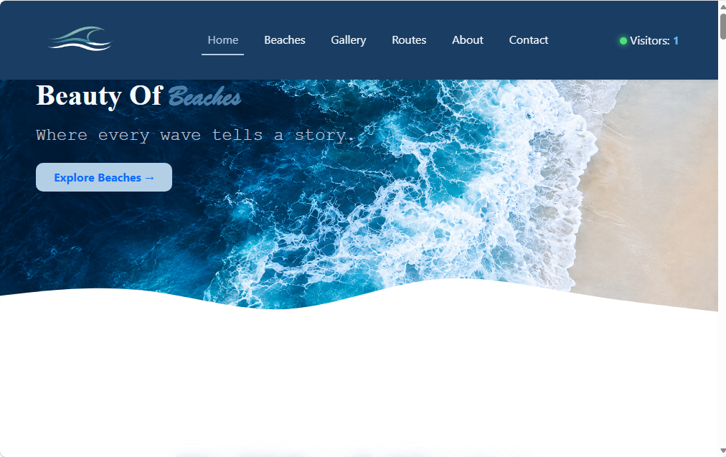
Navbar:


Hero Section: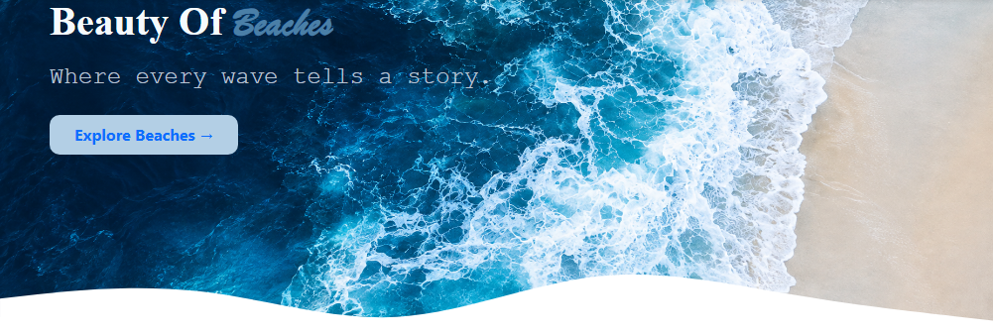

Popular Beaches: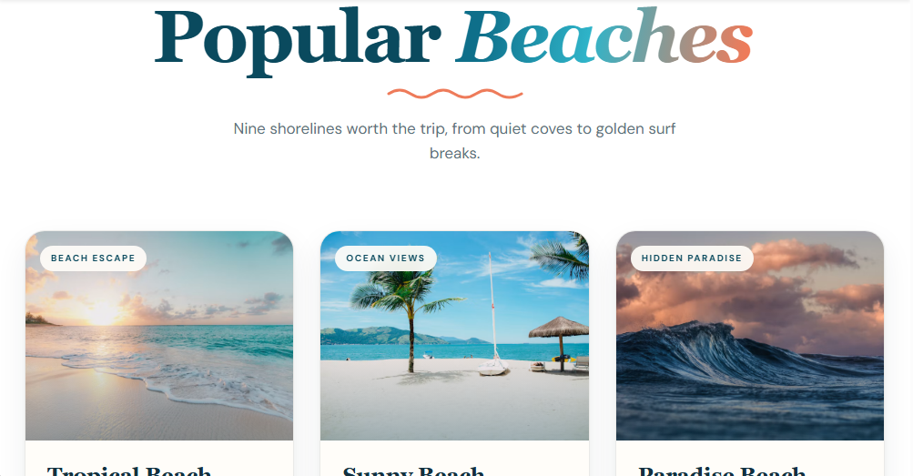

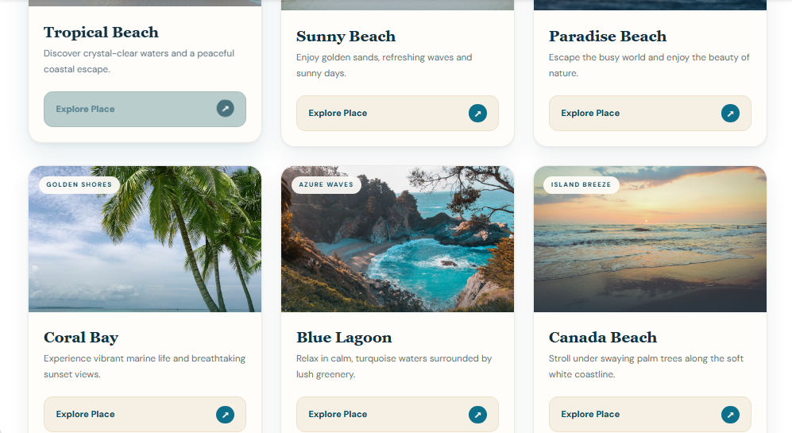

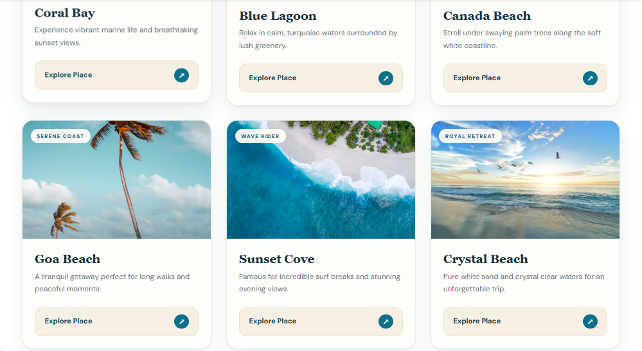

Beaches Zone Wise:
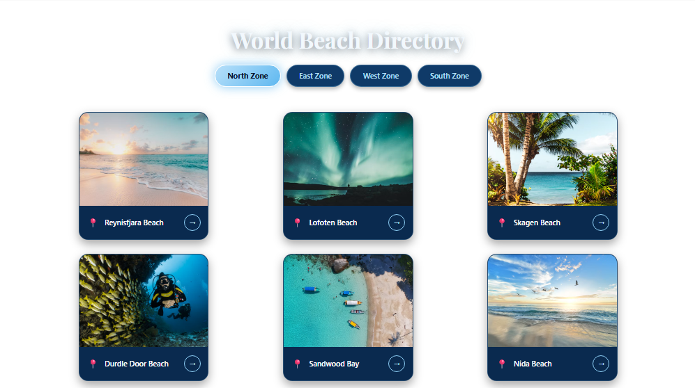

Gallery Section: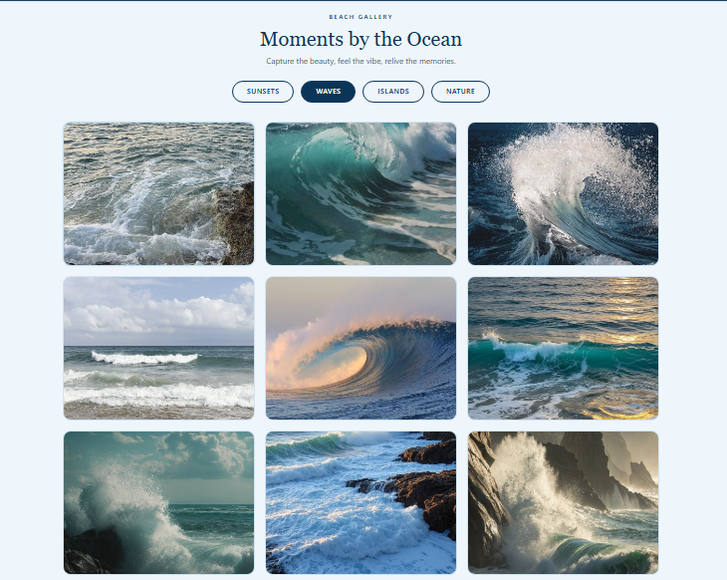
Routes Section: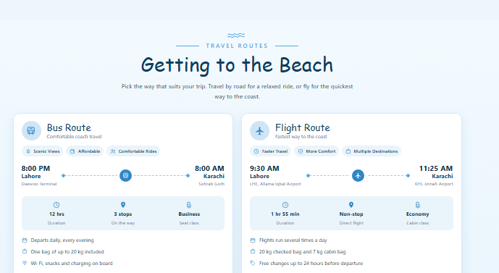

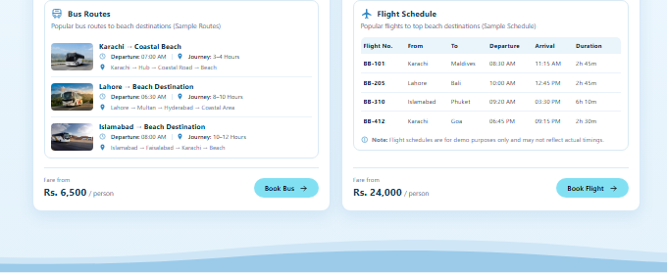

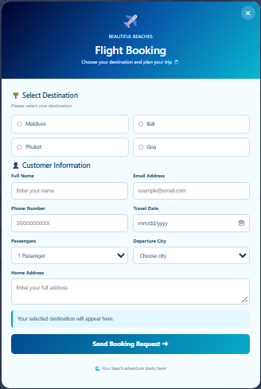
Routes Section Booking Modal:
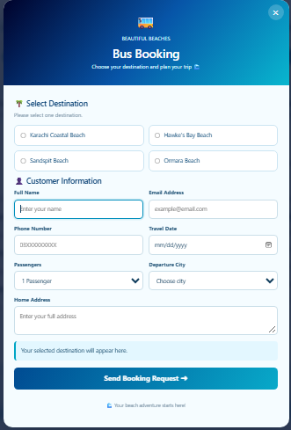

Review Section:
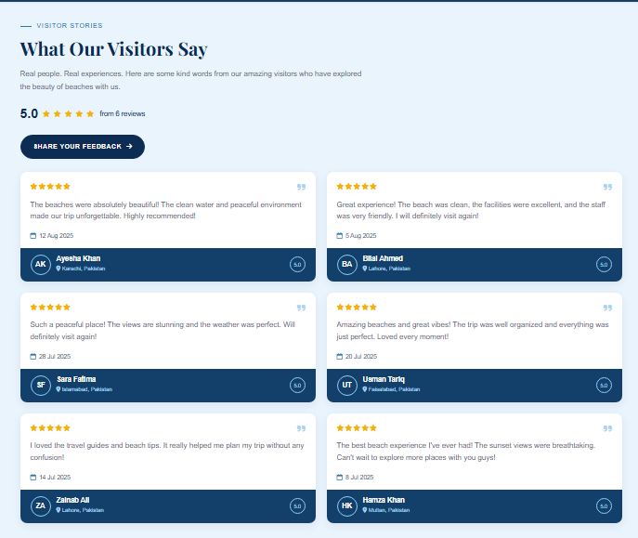

Review Submission Form:
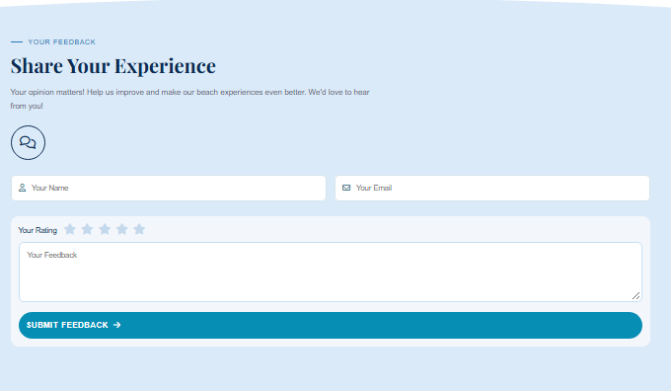

About Us: 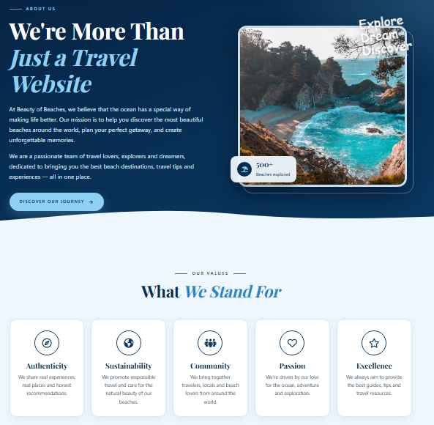
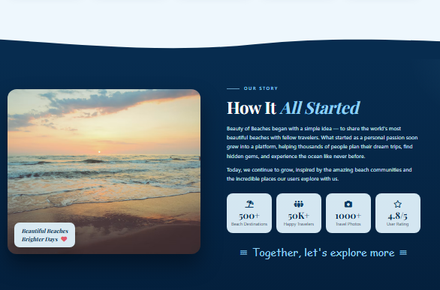

Contact Us: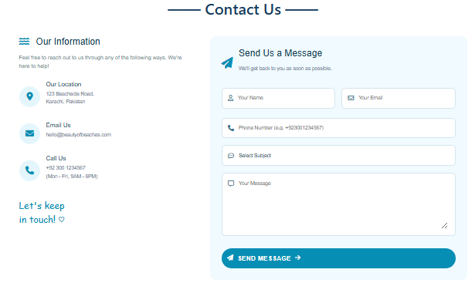
Footer:
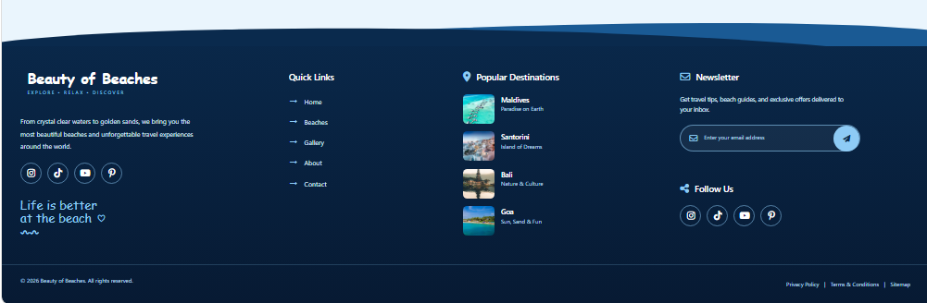

TASK ALLOCATION & WORK DISTRIBUTION SHEET
Task ID | Module / Activity | Assigned Member | Student ID | Status
TS-01 | Requirement Gathering, Core UI/UX Layout Sketching & Color Palette Selection | ZAIN UL HAQ | 1730727 | Completed
TS-02 | HTML5 Semantic Structure Markup (Hero Section, Cards Grid & Footer Layout) | ZAIN UL HAQ | 1730727 | Completed
TS-03 | Lead Front-End Development: Advanced Core CSS Architecture, Custom Brand Styling (style.css), & Typography Setup | ZAYAN AHMED | 1730756 | Completed
TS-04 | Complex Layout & Responsive Fixes: Bootstrap 5 Framework Integration, Fixing Critical Responsive Navbar Overflow Bugs & Cross-Device UI Testing | ZAYAN AHMED | 1730756 | Completed
TS-05 | Core Technical Implementation: Complex JavaScript Logic (script.js), Interactive Hero Slider Showcase & Dynamic Star Rating Filter Engine | RAHIM AHMED | 1730767 | Completed
TS-06 | Advanced Feature Architecture: Tabbed Zones Architecture, Heart-Icon Interactive Wishlist State Logic & jsPDF Library Integration for Dynamic PDF Export | STEPHNES BHATTI | 1733004 | Completed
TS-07 | Travel Route Table Layout, Traveler Reviews Component & Contact Form Validation | STEPHNES BHATTI | 1733004 | Completed
TS-08 | E-Project Documentation Report Writing, Updated Website Screenshots & Final Tasksheet Compilation | MUHAMMAD MUSTAFA | 1730760 | Completed

PROJECT PROGRESS MILESTONES
- Phase 1: Planning & UI Architecture
  - Finalized project scope, layout design, and initial UI specifications.
  - Set up modular project structure (index.html, style.css, script.js).
- Phase 2: Core Engineering & Responsive Layout
  - Built complete front-end layout with HTML5, CSS3, and Bootstrap 5.
  - Resolved critical CSS/Bootstrap navbar rendering issues across modern screen sizes.
- Phase 3: Advanced JS Features & Client-Side Logic
  - Built interactive slider and custom star rating filter modules.
  - Integrated tabbed Zones section, interactive heart-icon wishlist functionality, and client-side PDF document generation using jsPDF.
- Phase 4: Testing & Report Finalization
  - Cross-browser compatibility and responsiveness testing on mobile, tablet, and desktop viewports.
  - Updated member credentials, added fresh website screenshots, and generated formal academic report documentation.
CONCLUSION
The "Beauty of Beaches" e-project successfully demonstrates the practical implementation of modern front-end web development tools. By integrating HTML5, CSS3, Bootstrap 5, JavaScript, and external dynamic libraries like jsPDF, the team created a responsive, interactive, and visually engaging web application. The project enhanced our technical problem-solving capabilities, UI/UX design standards, and collaborative development skill
THANK YOU

